Practice Work No - 1:
Statement | Create an Azure account using any outlook/Gmail/Hotmail id.
Objective | The main objective of the task is to create an Azure account using a mail id and Credit card.
Outcomes | After executing this, one should be able to create a personal/corporate azure account.
Prerequisites | Email id, PAN Card (not mandatory), Credit Card (mandatory), Internet.

Follow below steps to create an azure account using credit card.
- Create a new account using “outlook.com” or any other ID.
- Login to: https://azure.microsoft.com/en-us/
- Click Start Free.
- Fill your mail ID.
- Fill PAN details.
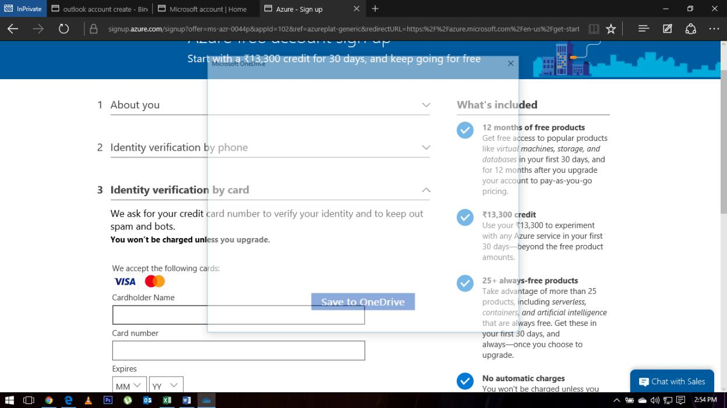

- Fill card details
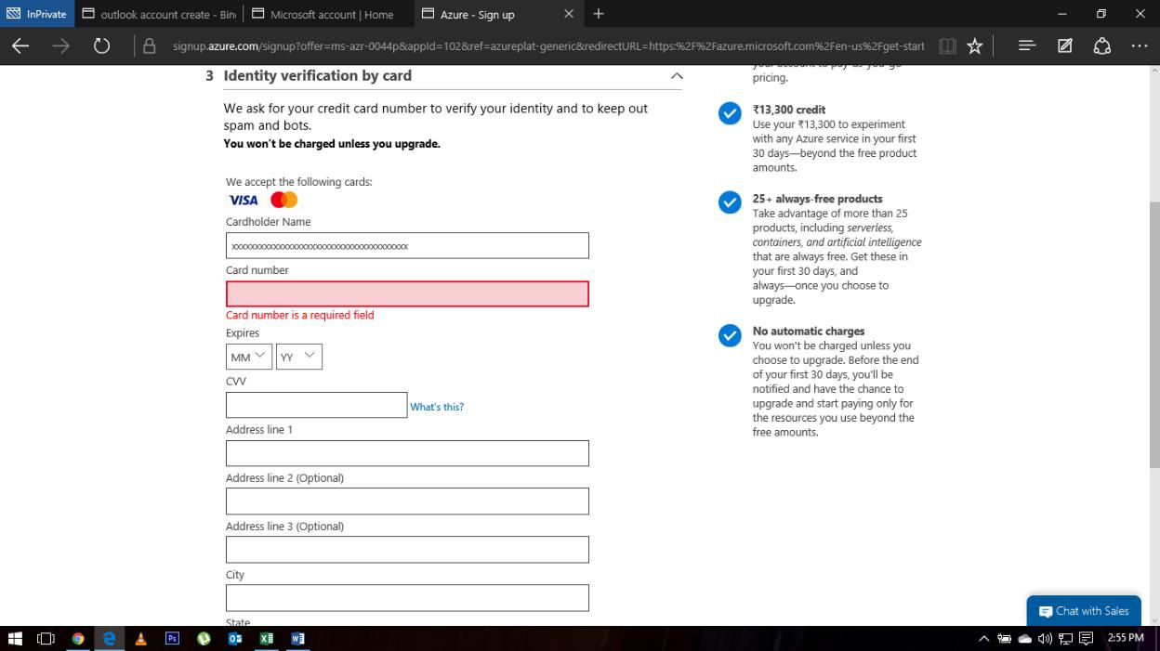

- Fill details & give OTP.
- Click “I agree...” & then signup
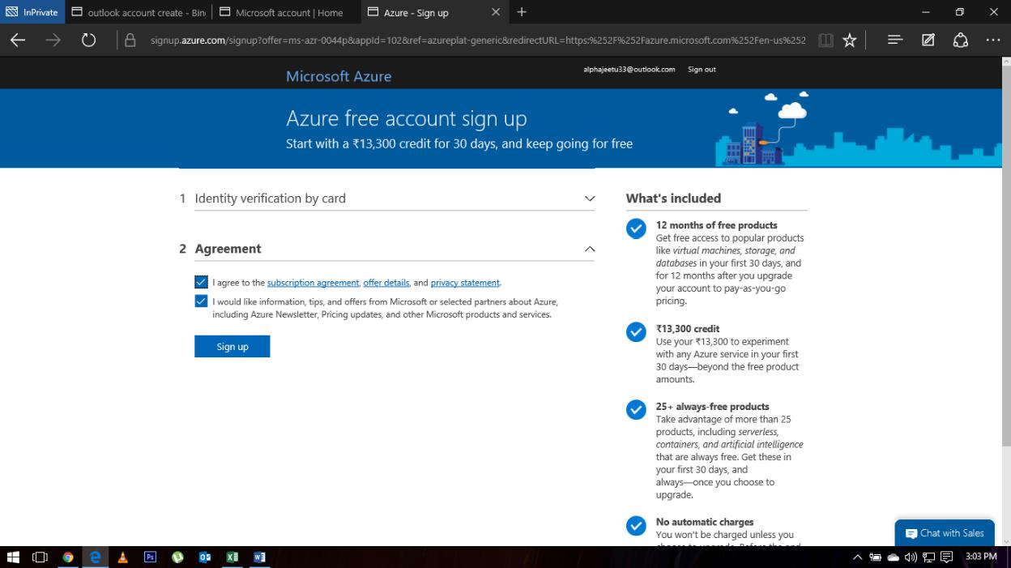

- Login to: https://portal.azure.com/#home

- Something like this will be visible.
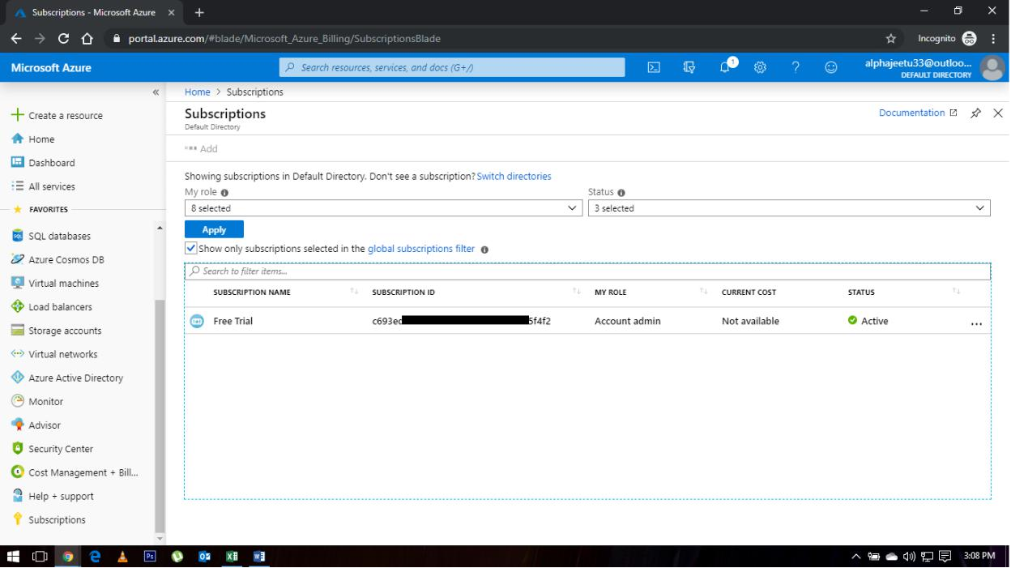

Practice Work No - 2:
Statement | Implementing Azure Active Directory.
Objective | The main objective of the task is to create and manage Azure Active Directory using Azure portal.
Outcomes | After executing this, one should be able to create and manage the azure Active Directory.
Prerequisites | Working Azure account, Internet
[Task]: Create users in bulk using Active Directory on portal.
Switch to azure active directory blade & select Users blade.
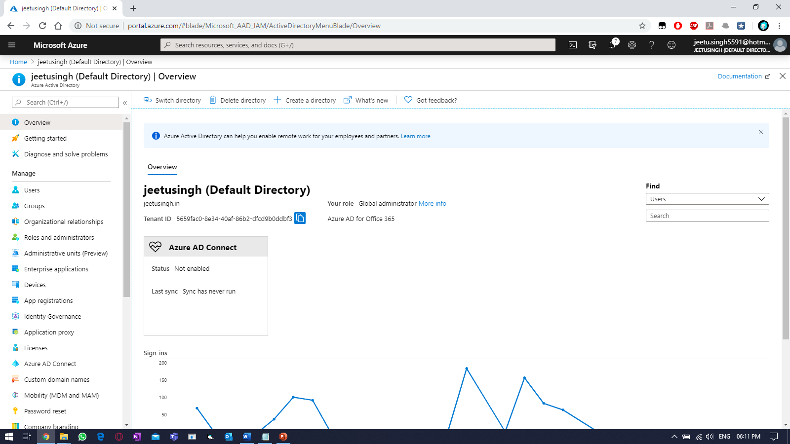
Under USERS, select “Bulk Create” tab.
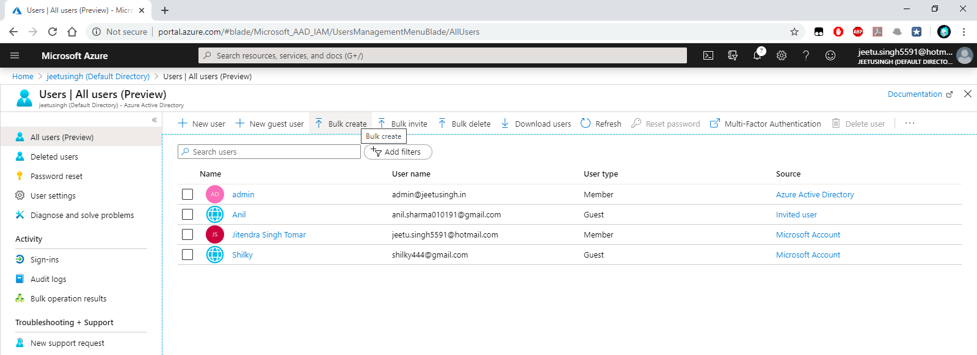

Download the default CSV and edit the content & upload it from the same portal.
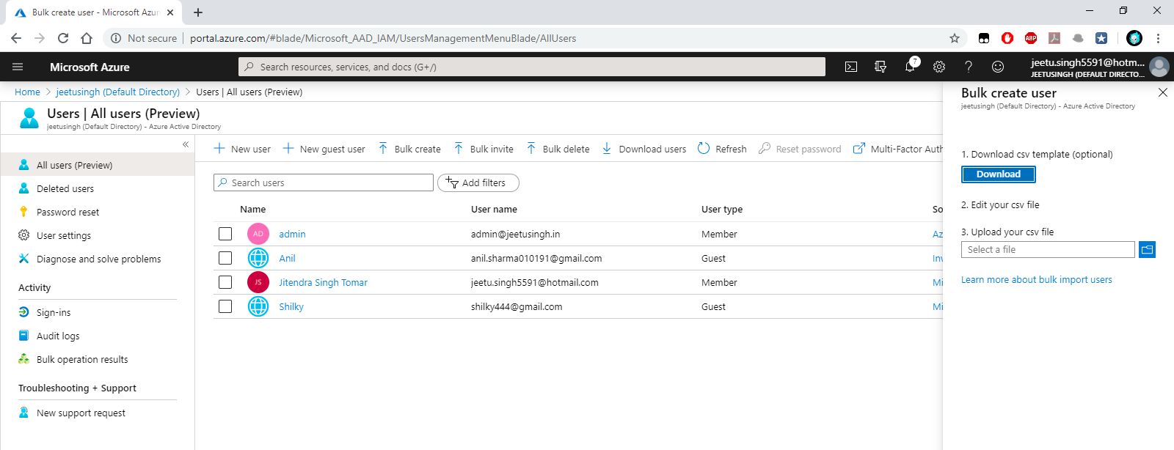
Editing the CSV.
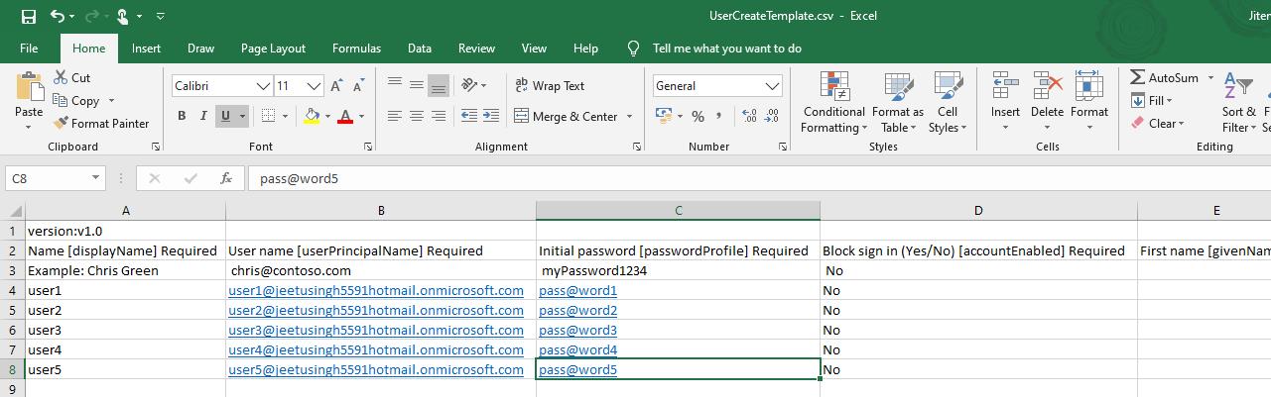
Uploading the CSV.
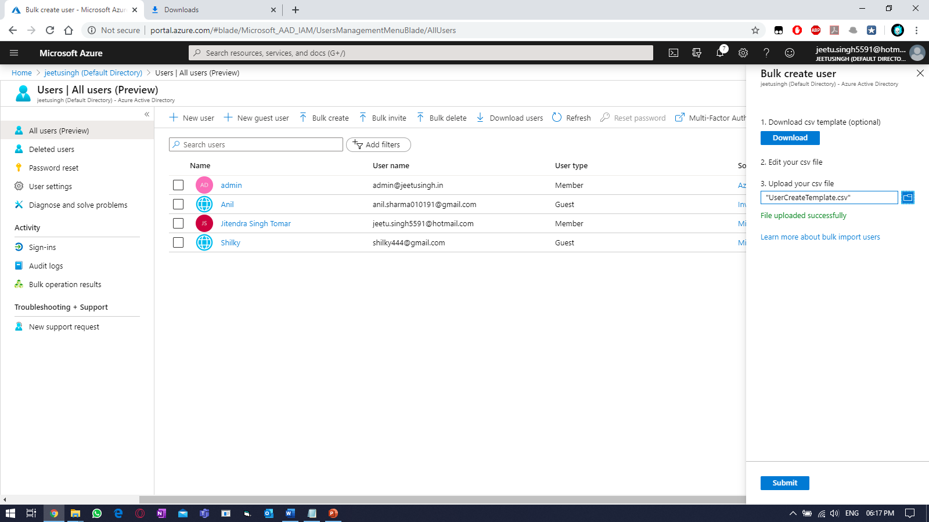

Refresh the azure portal.
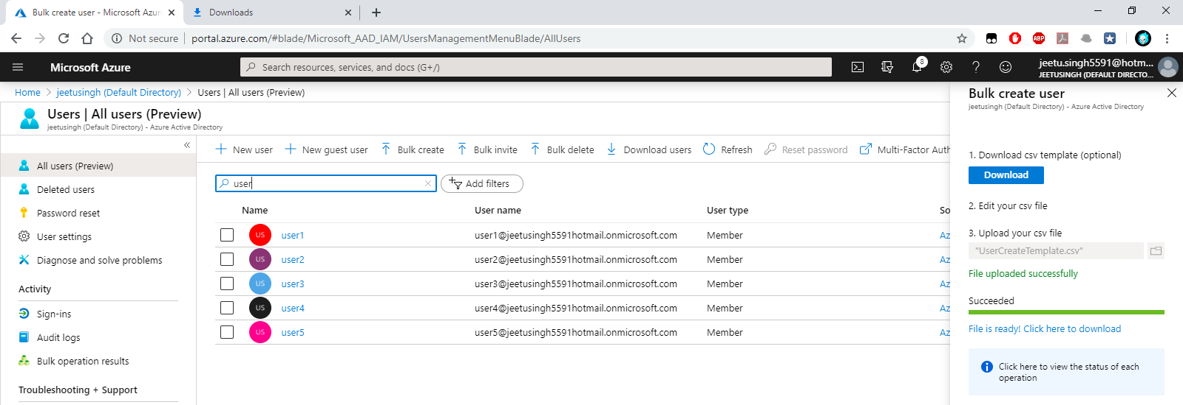
Login-in using the newly created user.
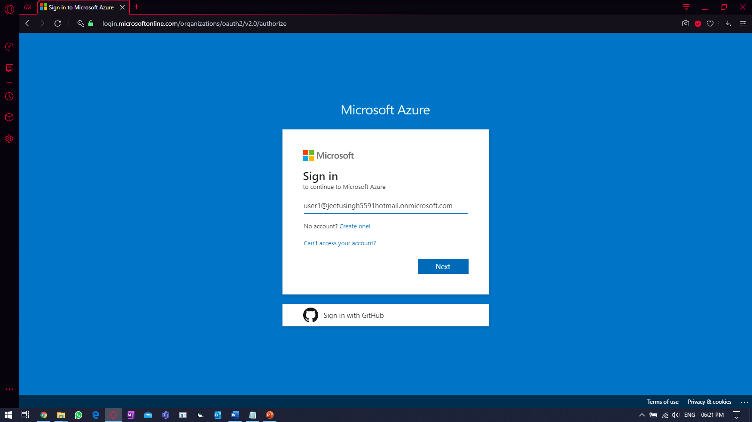
Providing password.
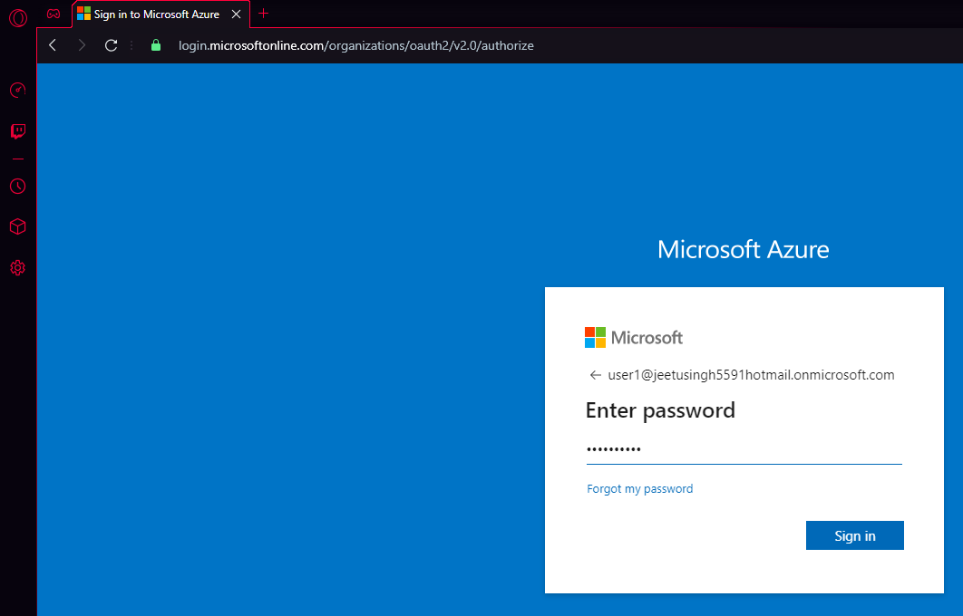
Providing new password
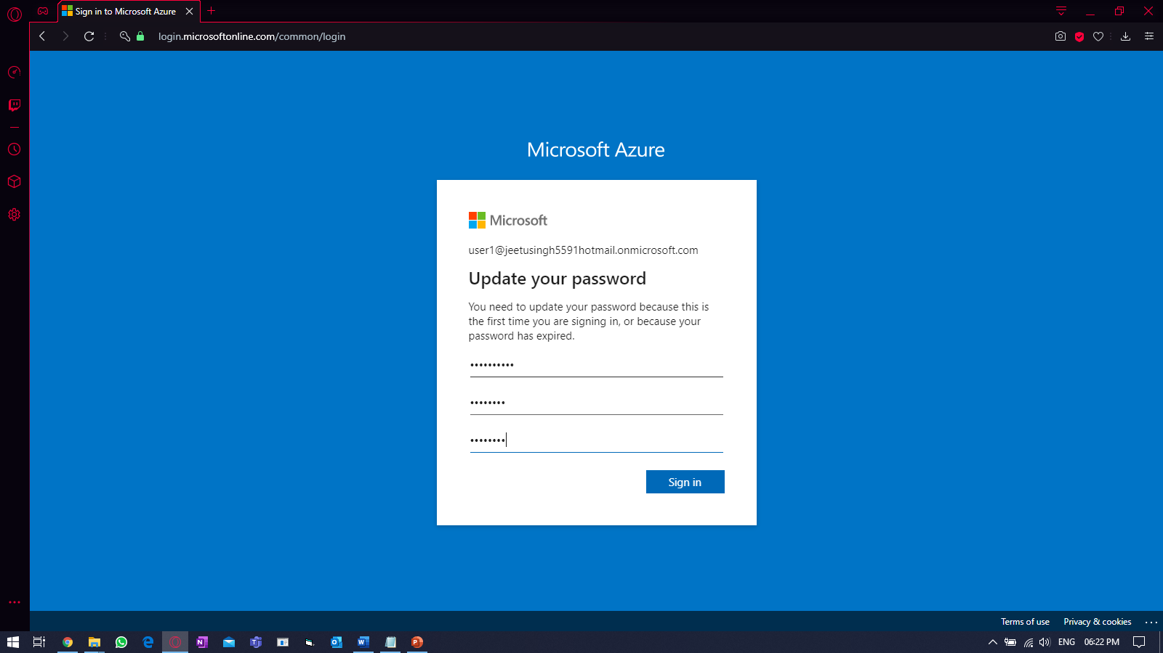
Login-in to portal.
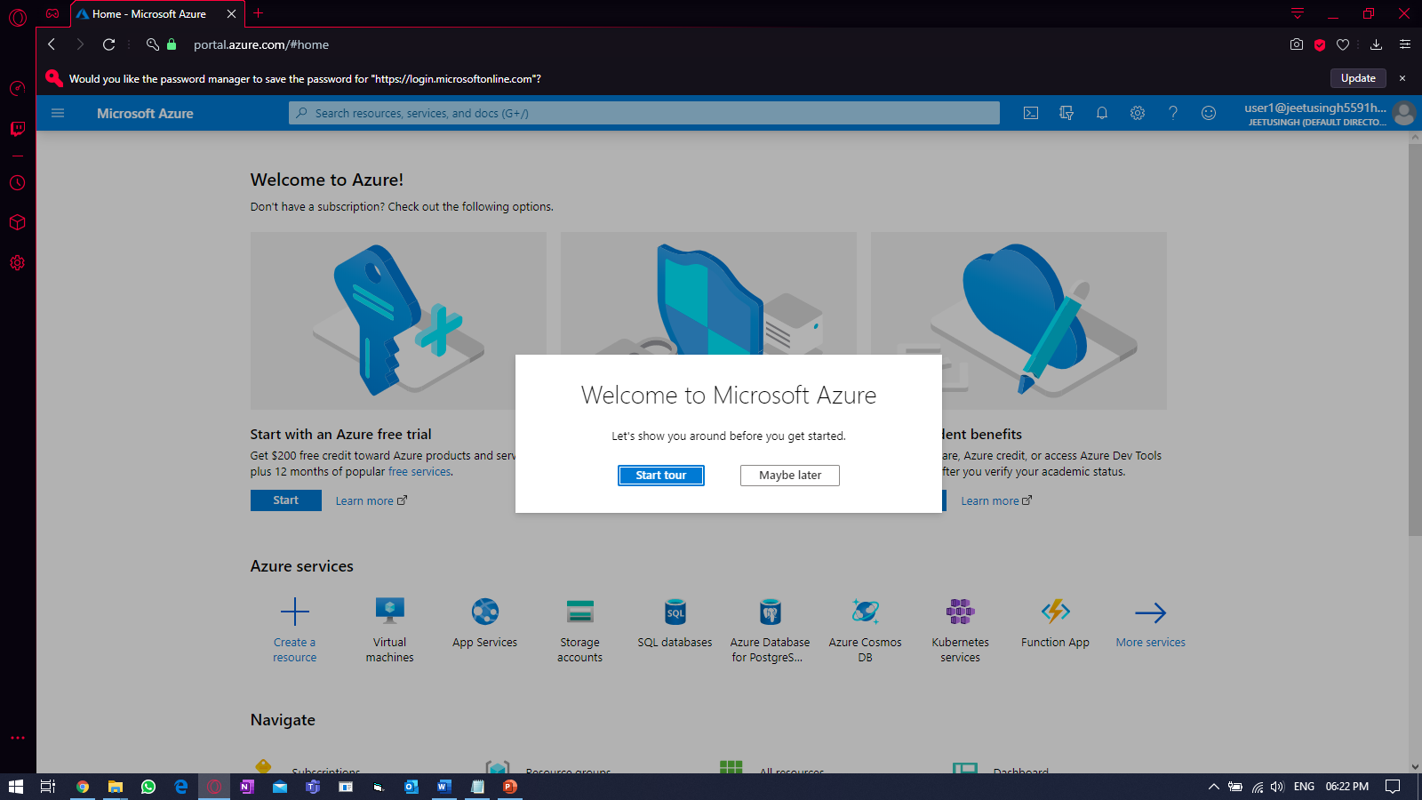

Practice Work No - 3:
Statement | Implementing Multi-factor Authentication.
Objective | The main objective of the task is to enable extra step of security for users
Outcomes | After executing this, one should be able to implement MFA
Prerequisites | Working Azure account, Internet
[Task]: Enabling MFA for users
In active directory dashboard, click on users and click on Multi-factor authentication
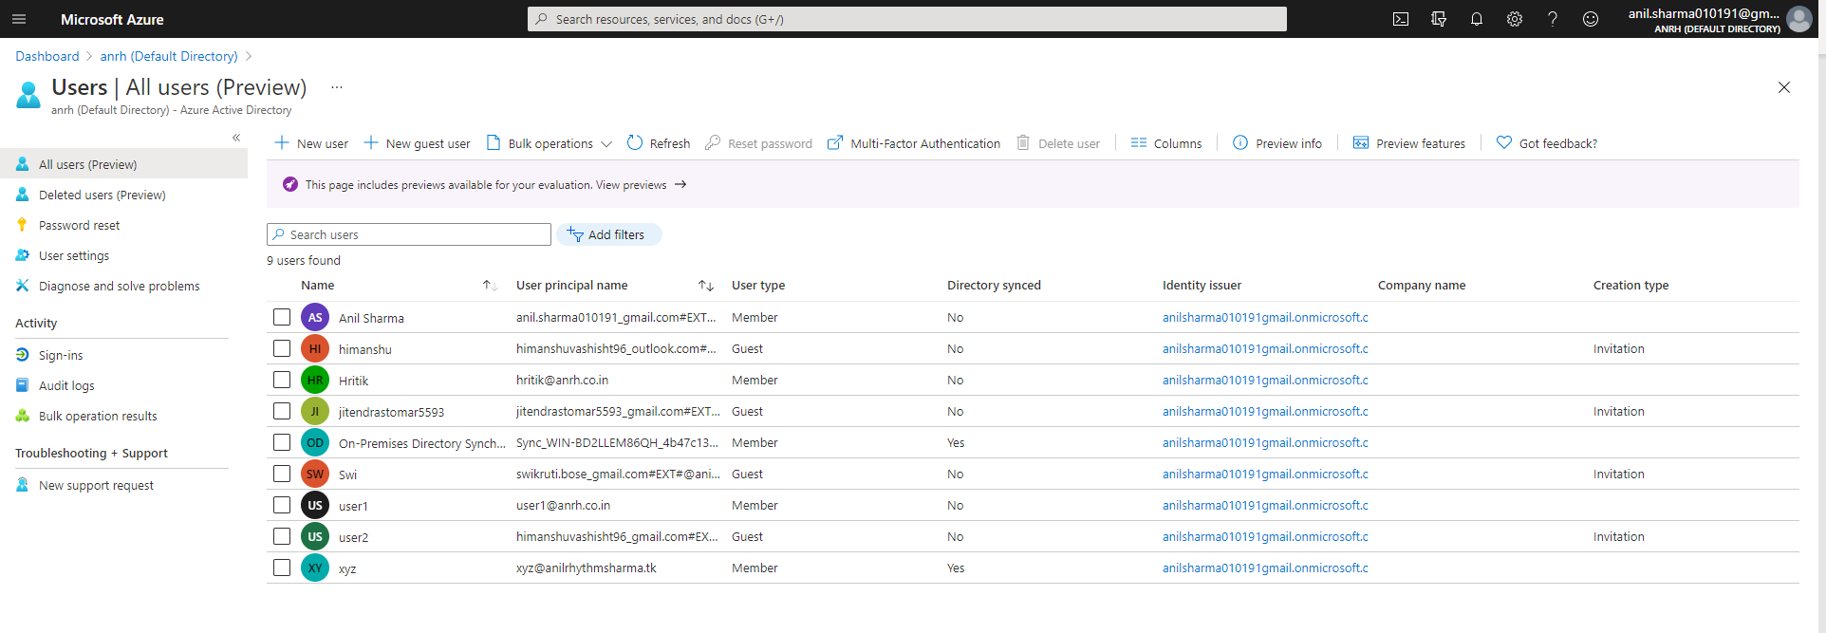
Select user and click on Enable on right pannel.
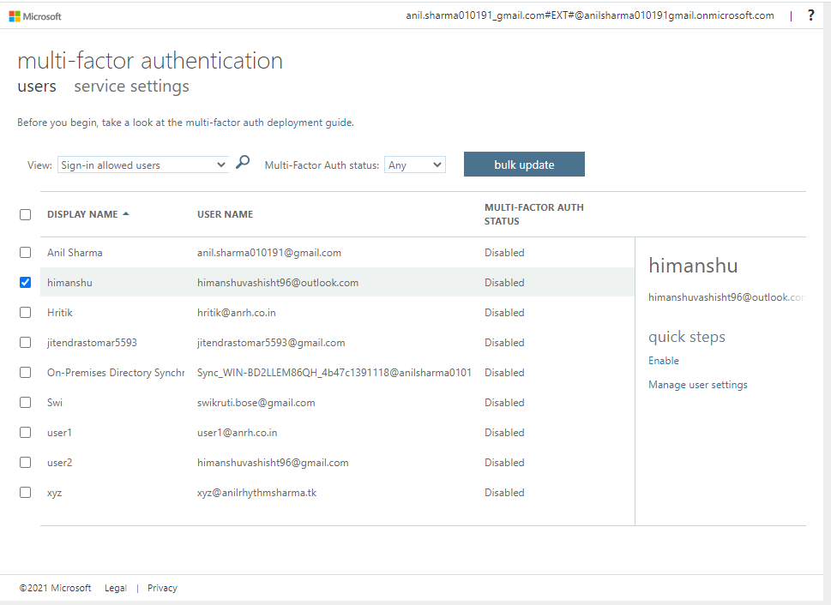

Practice Work No - 4:
Statement | Implementing and managing Azure networking.
Objective | The main objective of the task is to create and manage Azure network using Azure portal.
Outcomes | After executing this, one should be able to create and manage the azure virtual network (vnet).
Prerequisites | Working Azure account, Internet
[Task]: Create a virtual network using IP address range as (172.16.0.0/16) and with 3 subnets.
Step1: Create a new resource group in any region of your choice.
Select “Resource Group” on left hand side.
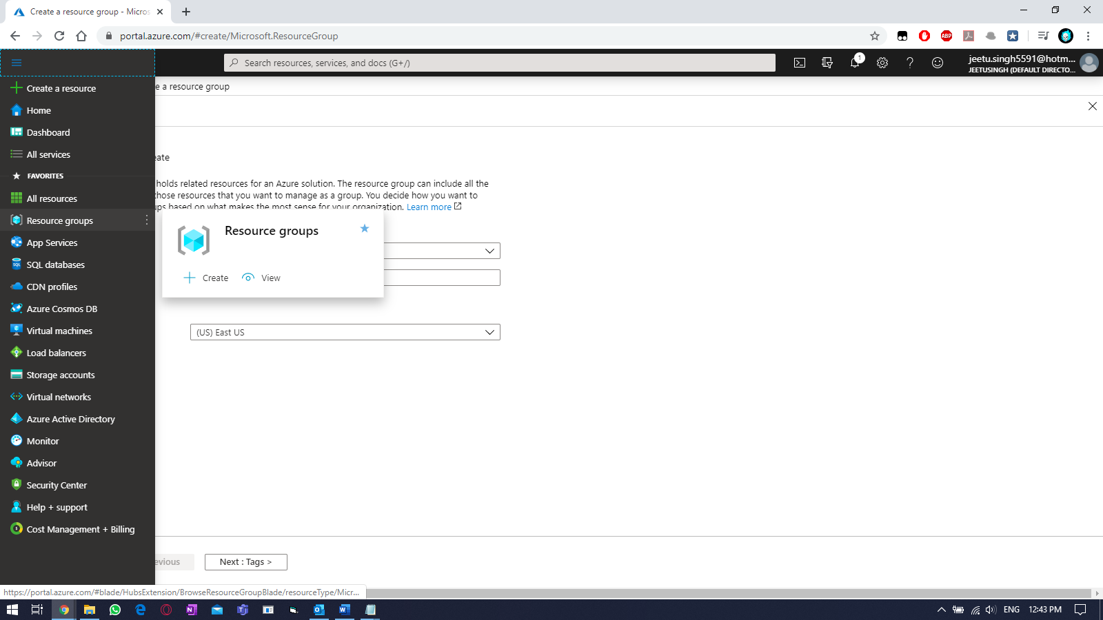

Click on Resource Group and fill the details like RG name & location.
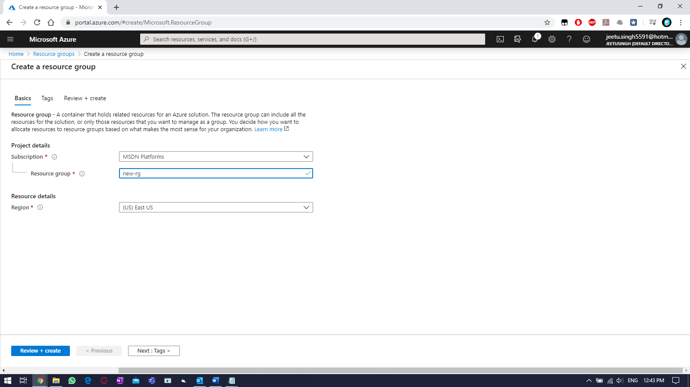
Then click on “TAGS” and fill the tags value (for billing)
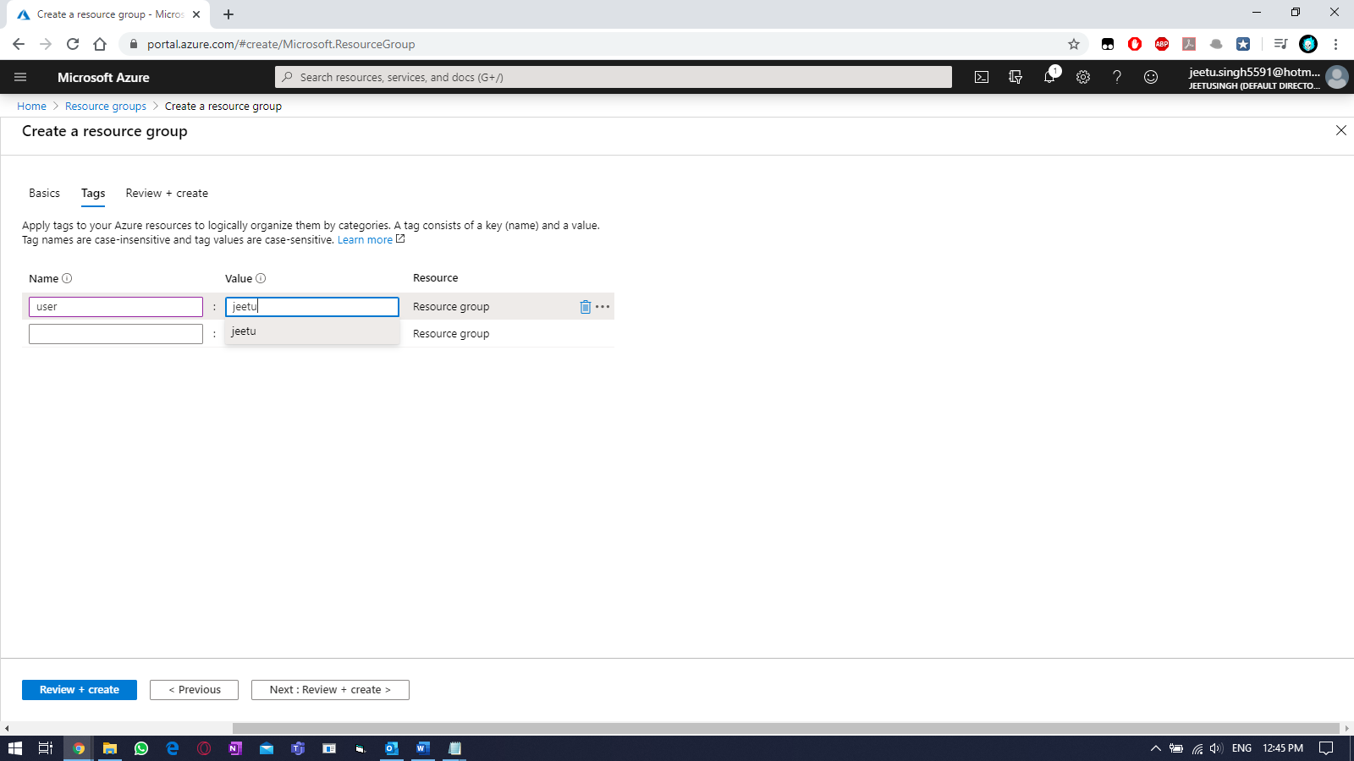
And click on “Next: Review + Create >”

Click on “Create” once validation is passed.
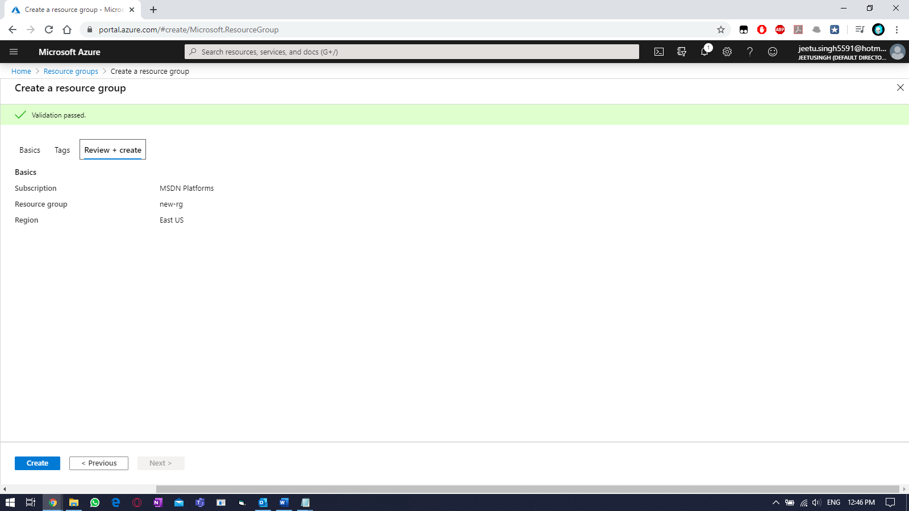
Verify.
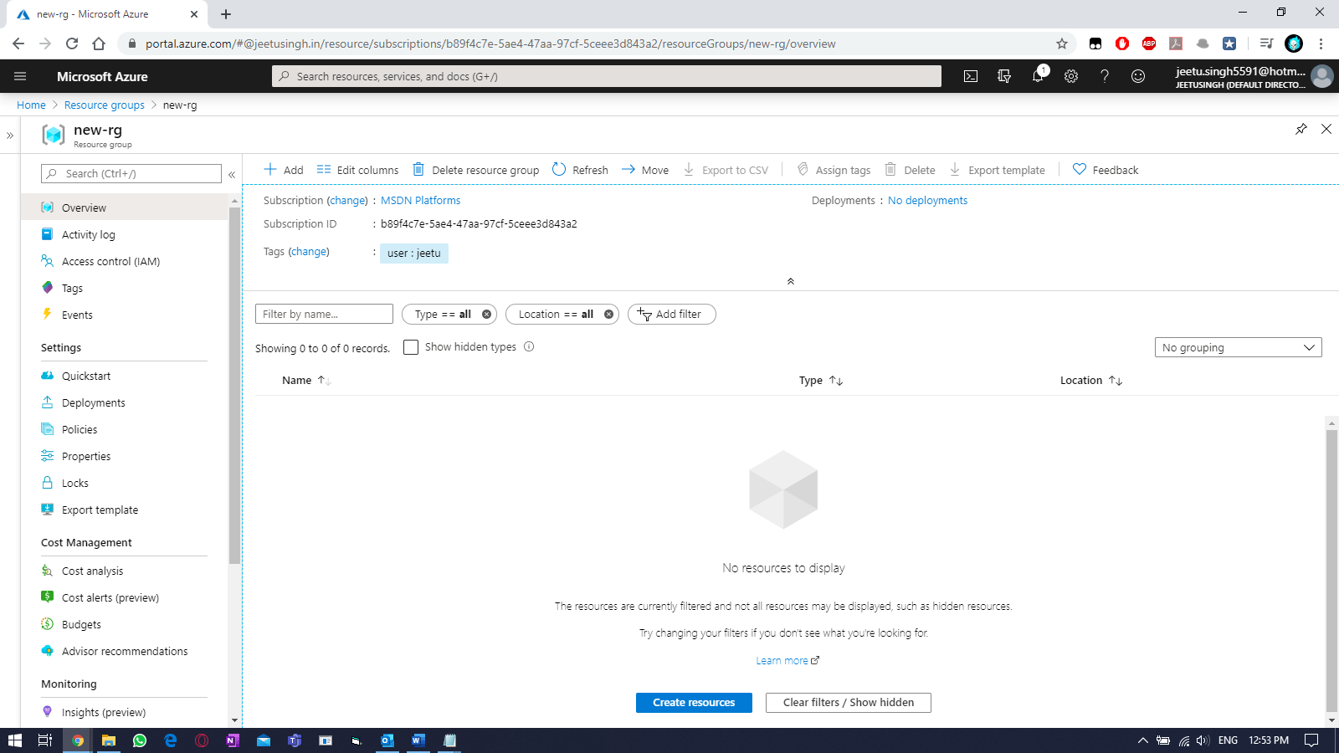

Step2: Create a virtual network (vnet) in the above RG using same region/location as RG.
On left side, click on ellipses (3 small lines) & select virtual network.
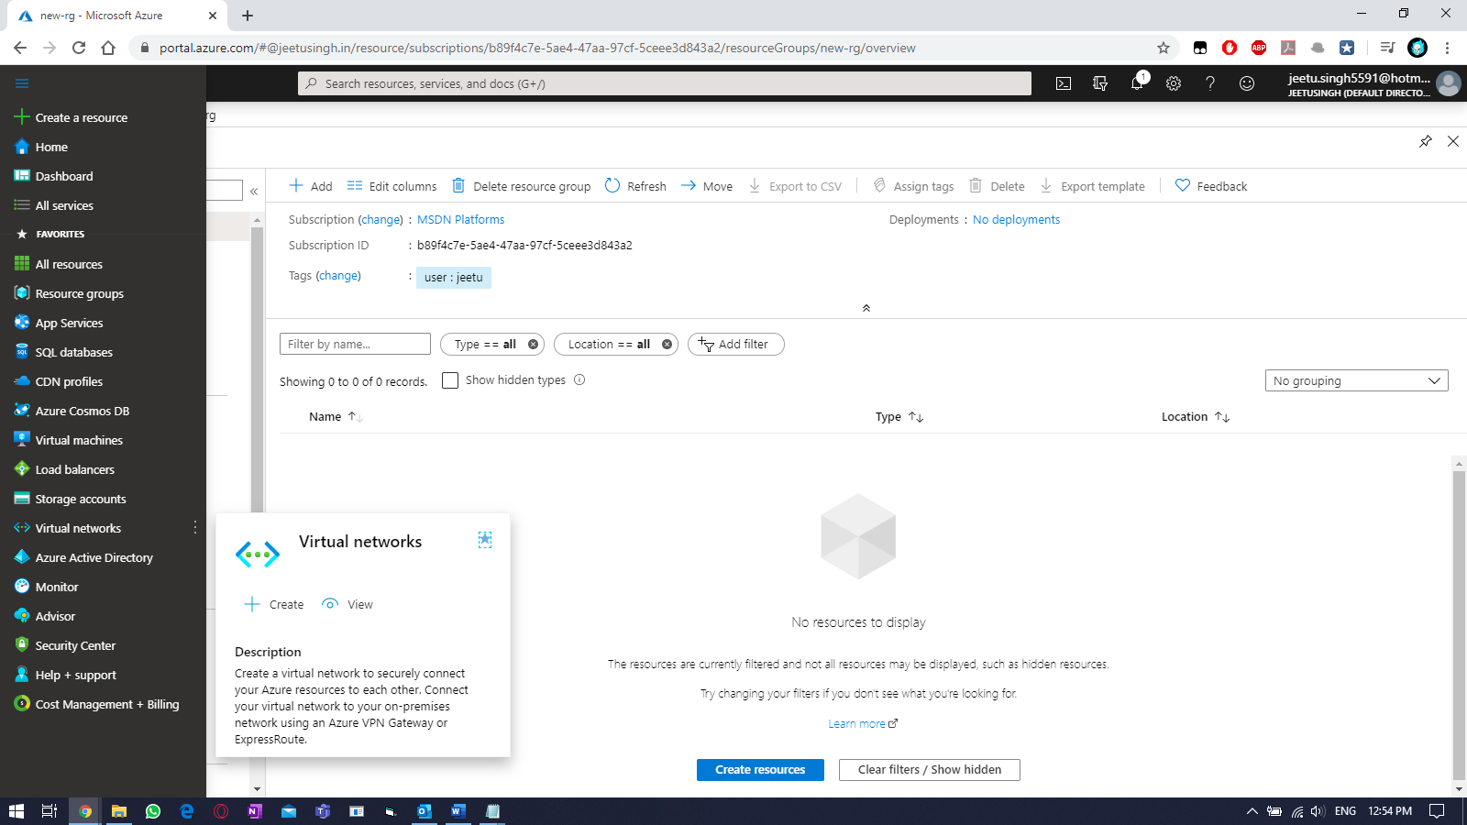
To create a new vnet, click on “+ADD” or “Create Virtual Network” button. Fill the required details.
- Resource Group (RG) → new-rg
- Name → newrg-vnet
- Region → ‘East US’
And then click on “Next: IP Addresses >”
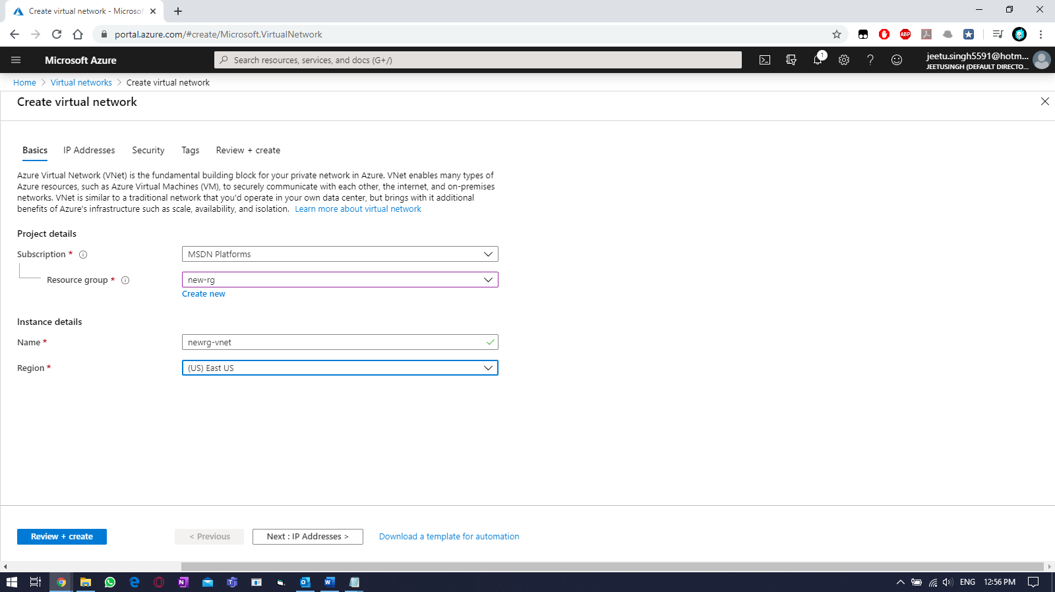

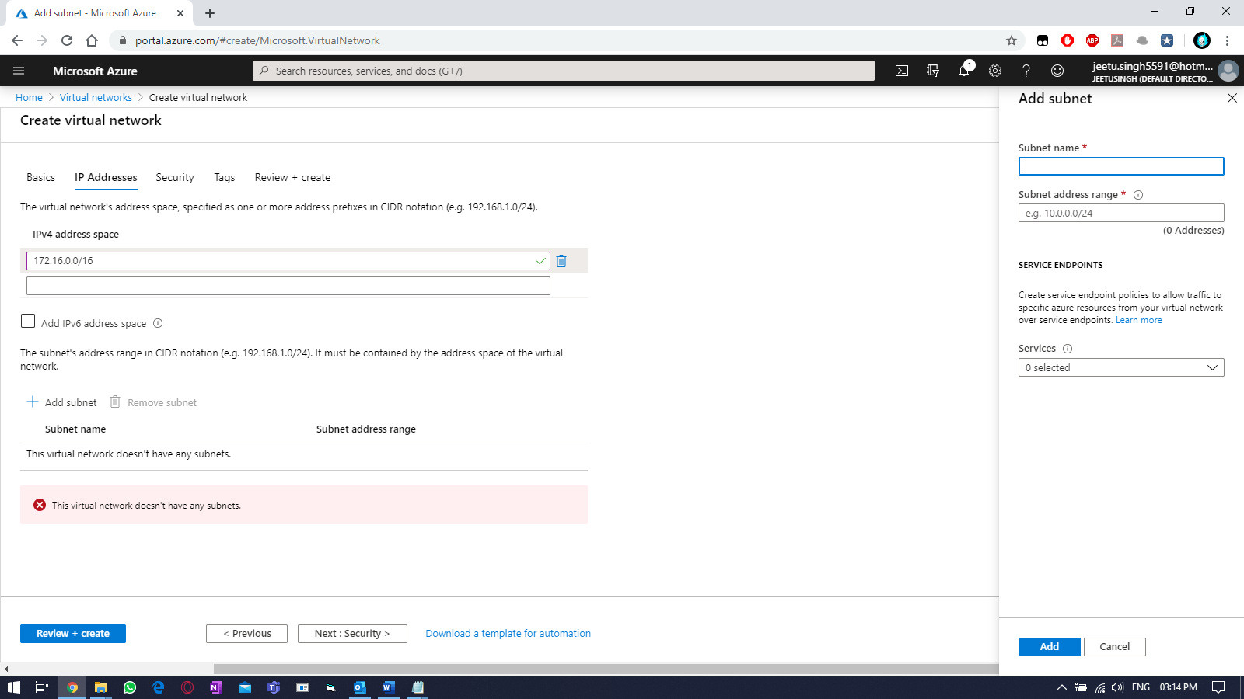
Creating subnets:
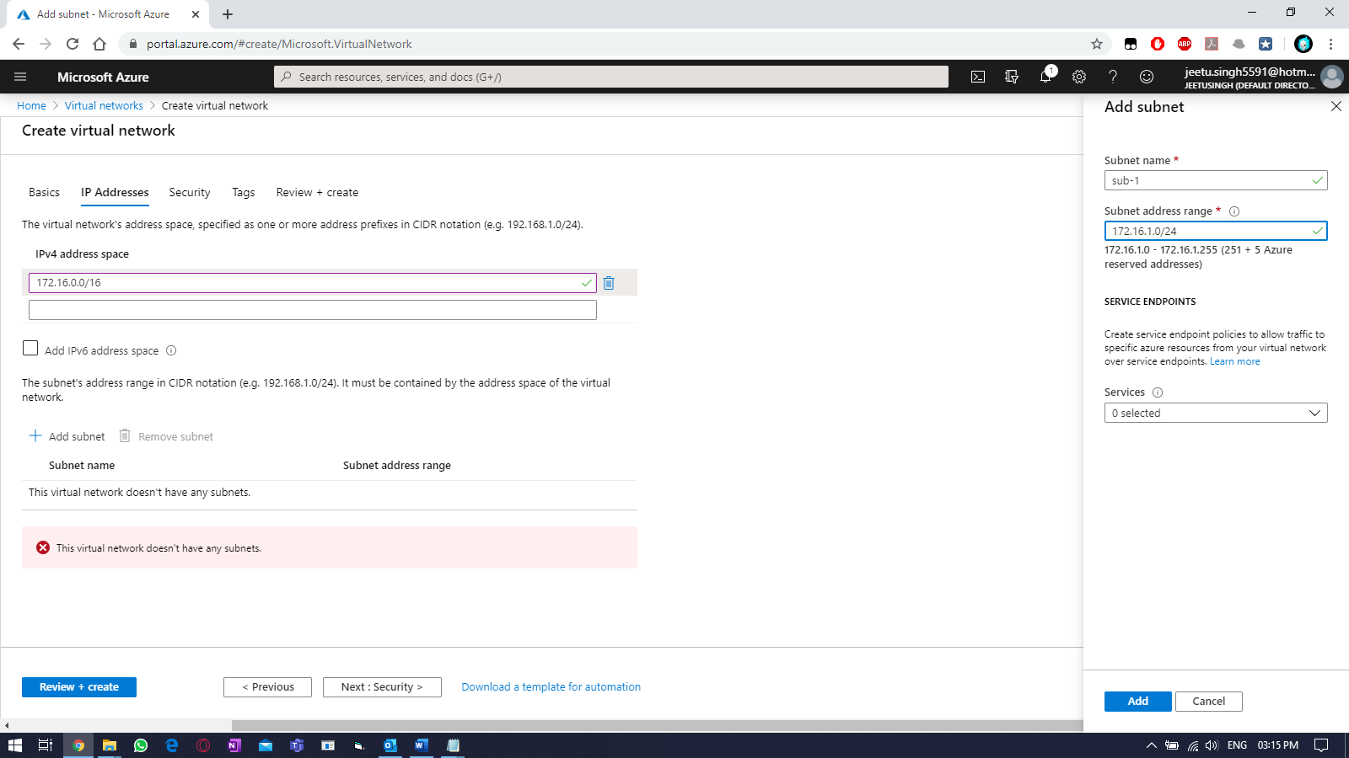

Creating 2nd subnets.
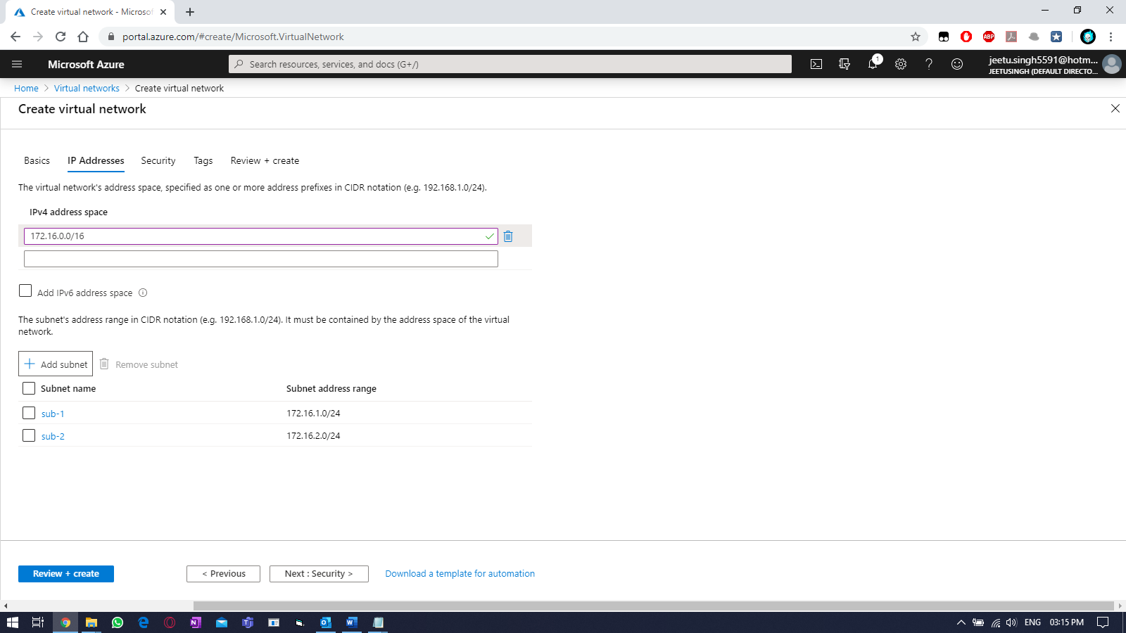
Select defaults for “Security”
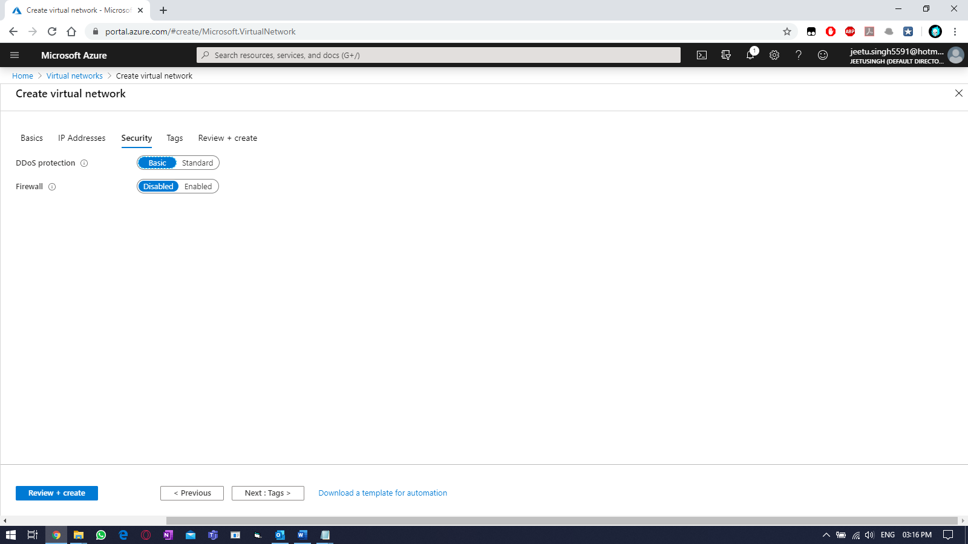

Select the tags:
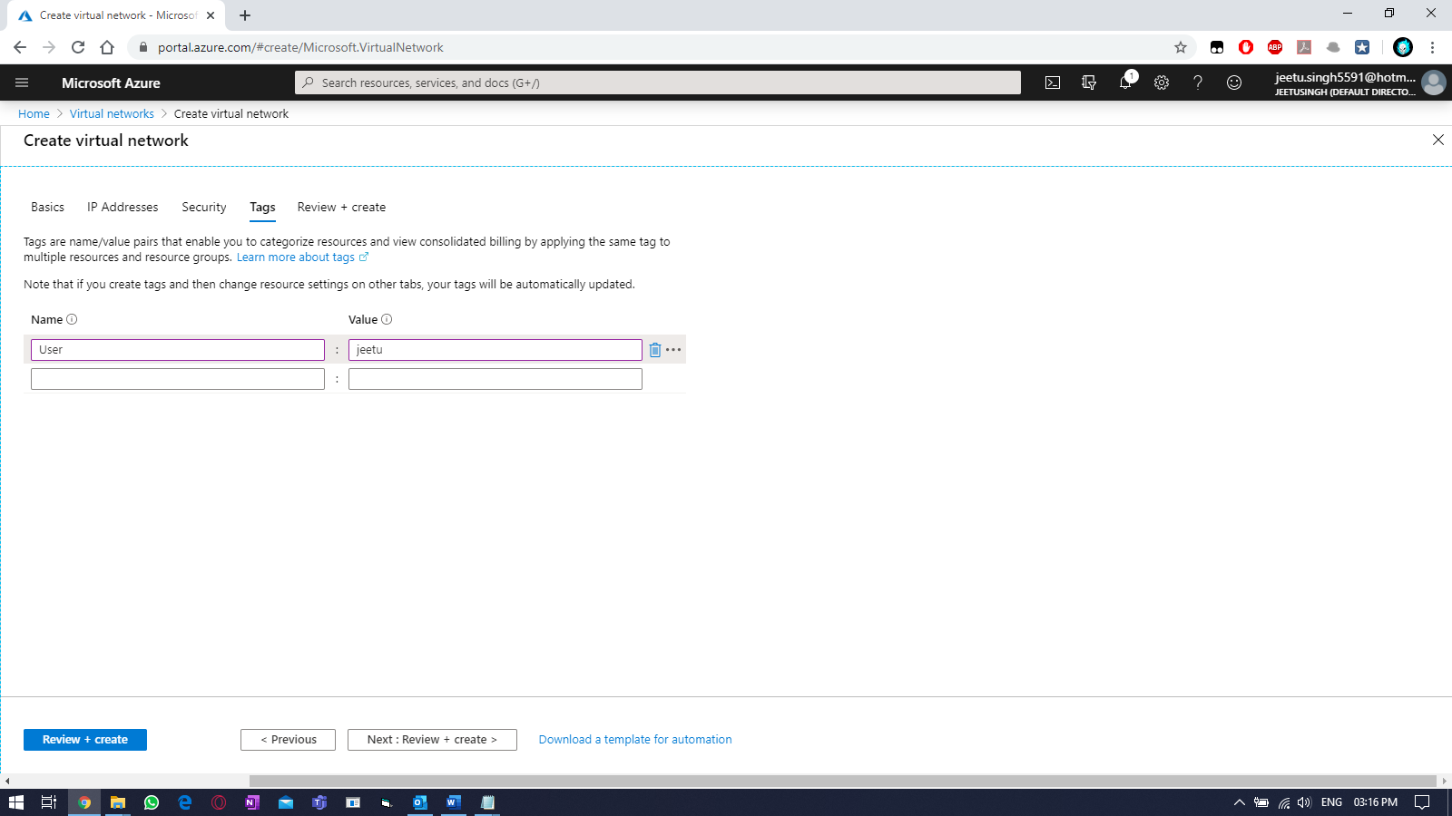
Once validation passed, click on “create”.
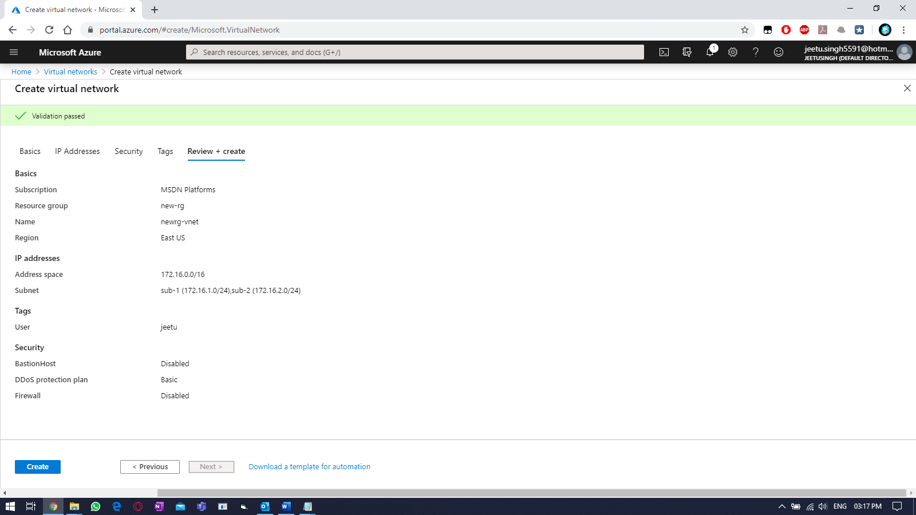

Wait for the deployment to get finished.
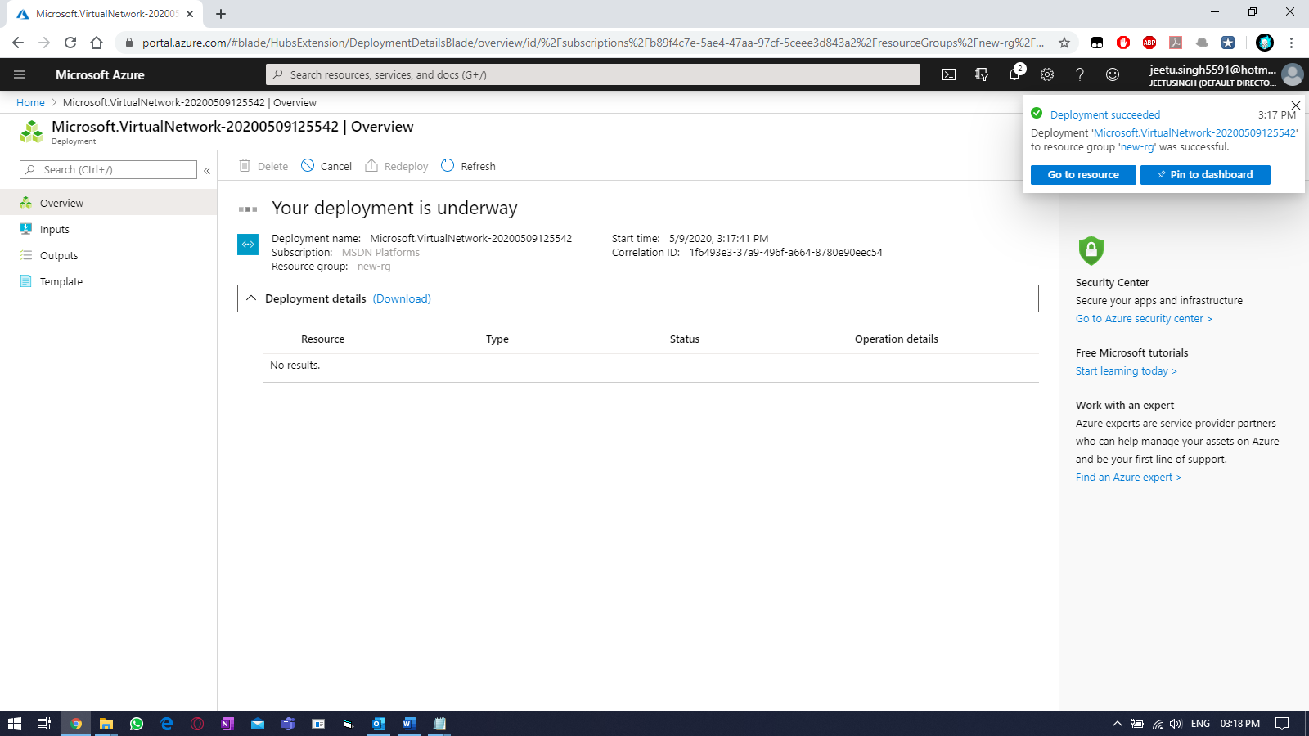
Click on “Go to resource”
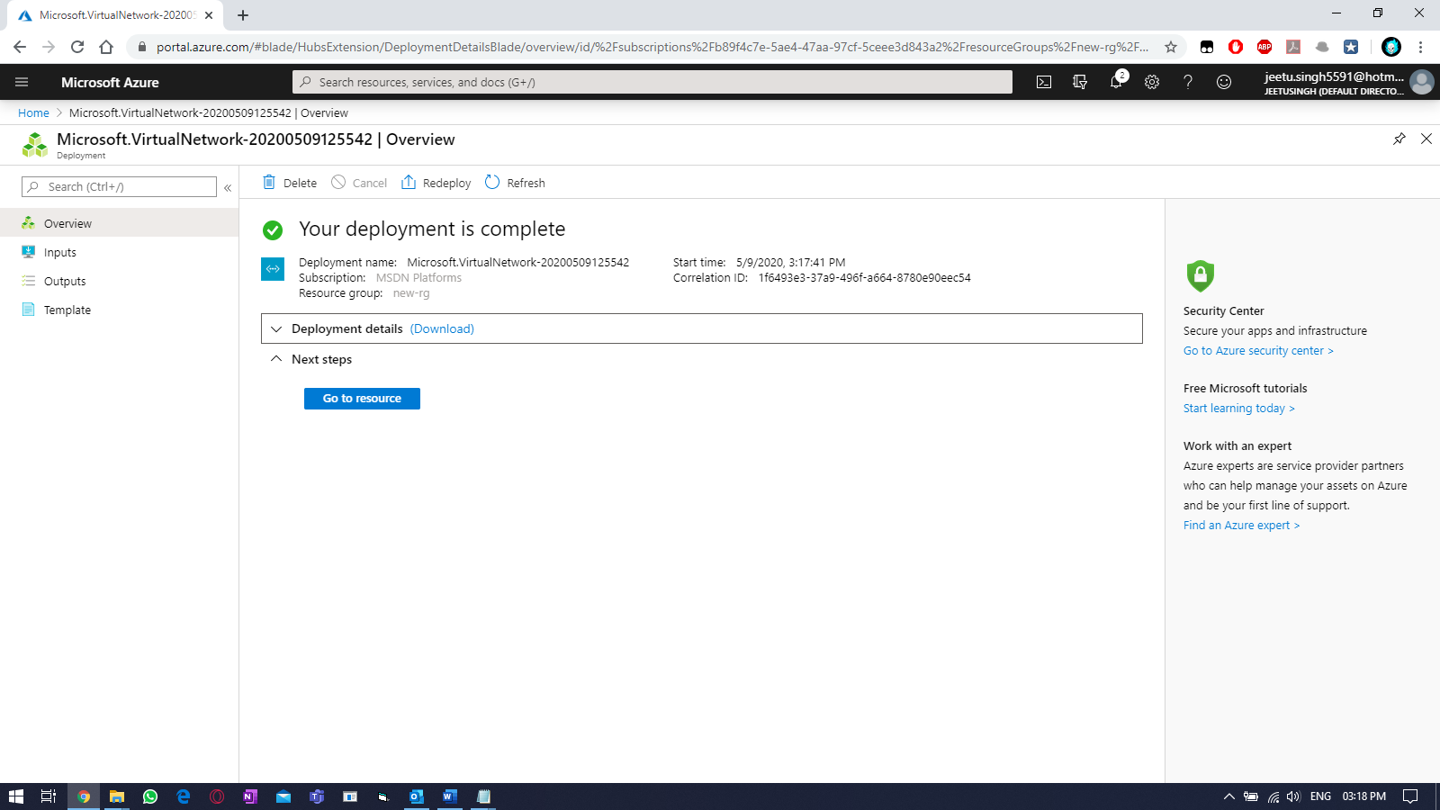

On left side, select Virtual network and select your vnet.
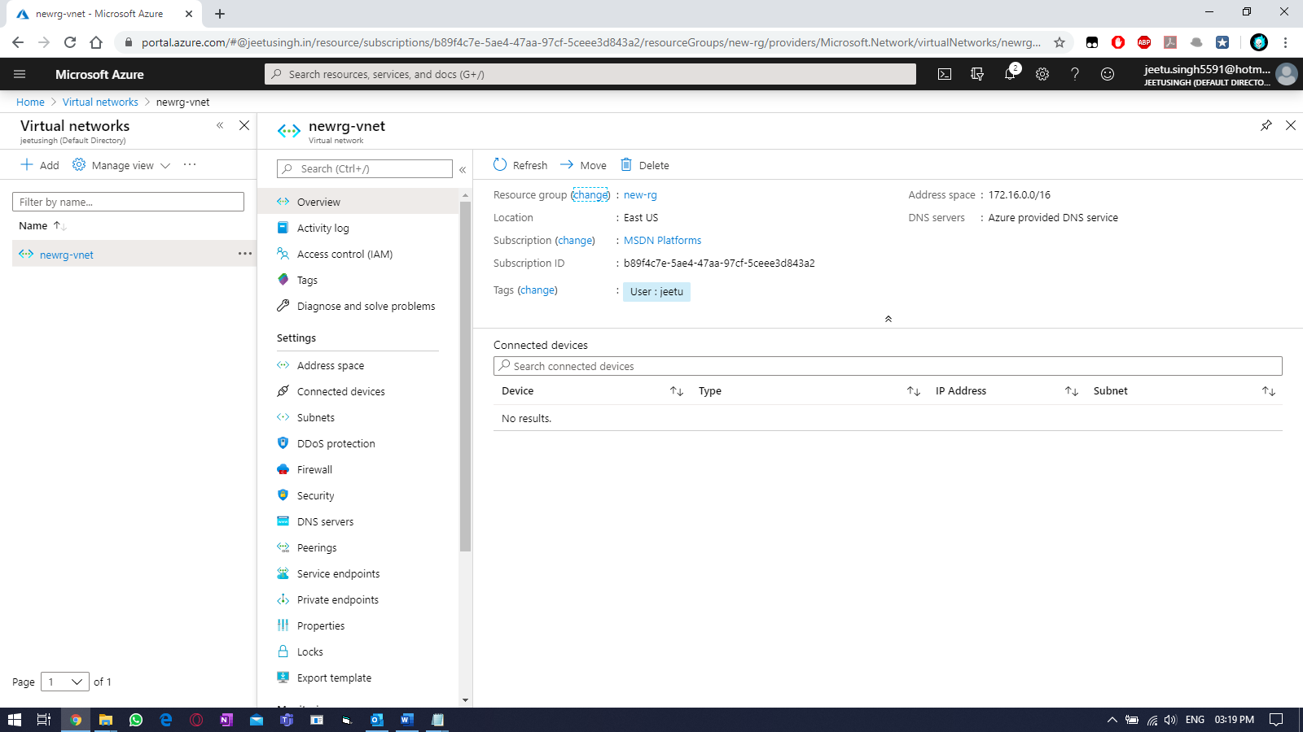
Adding 3rd subnet and adding a DNS server.
Select “subnets” within the vnet you created earlier, select “+Subnet” to add another one.
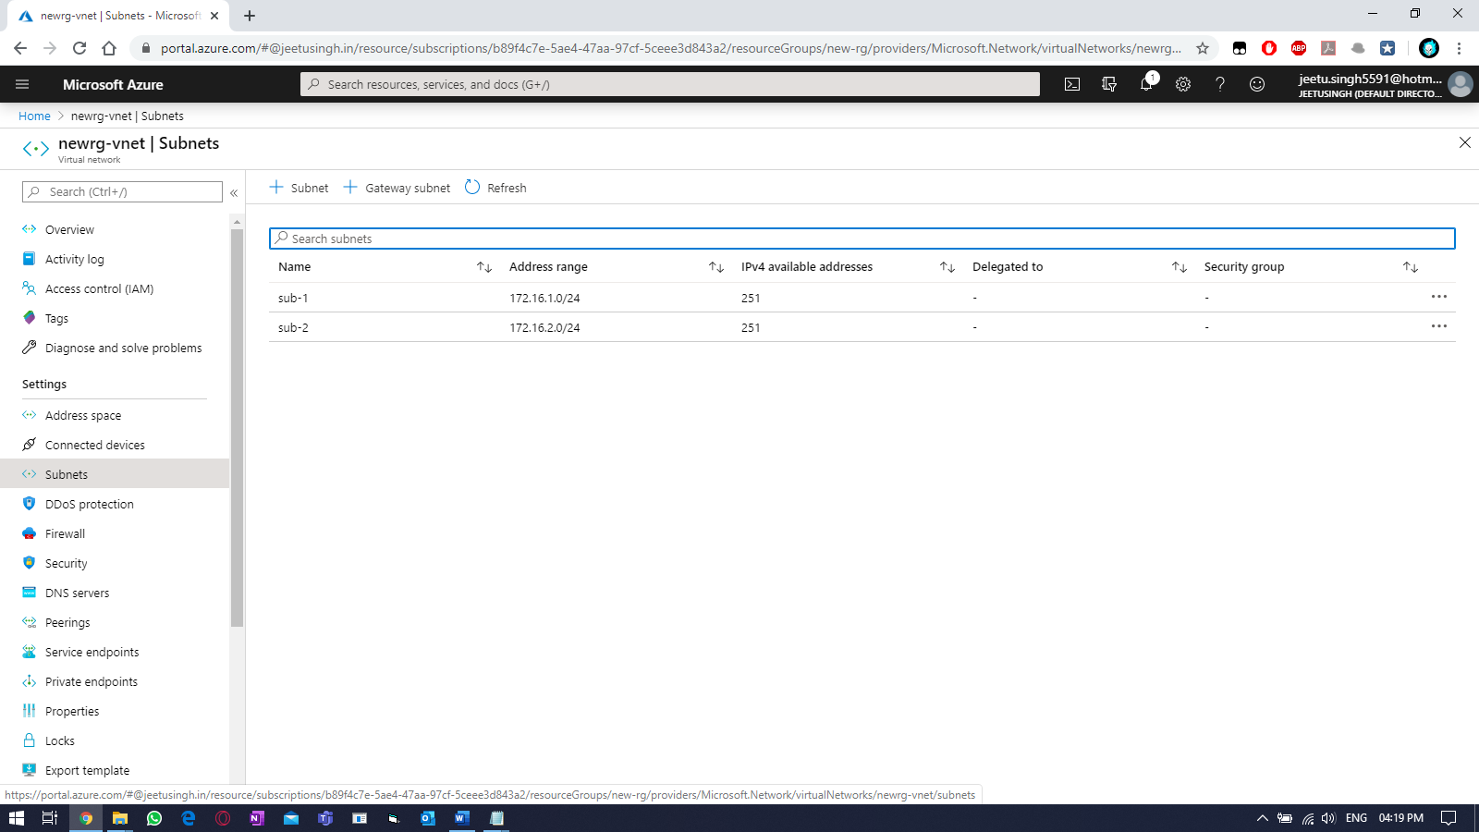

Fill required details. Then select “OK”
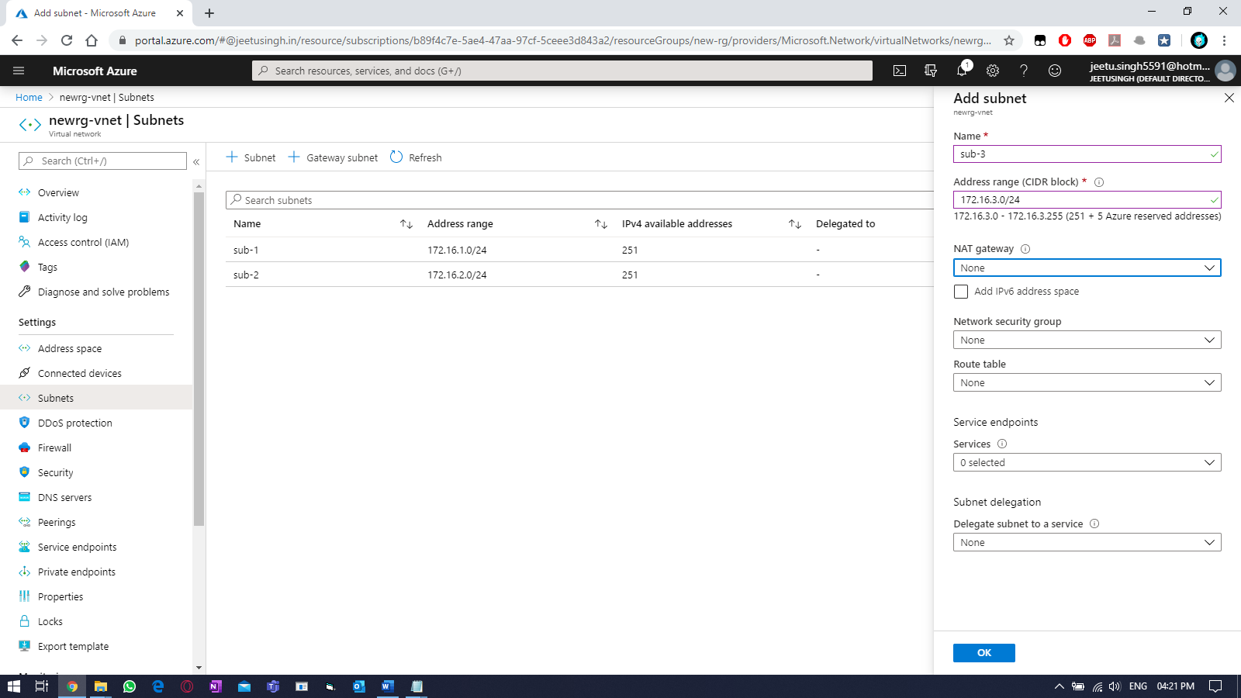
& verify.
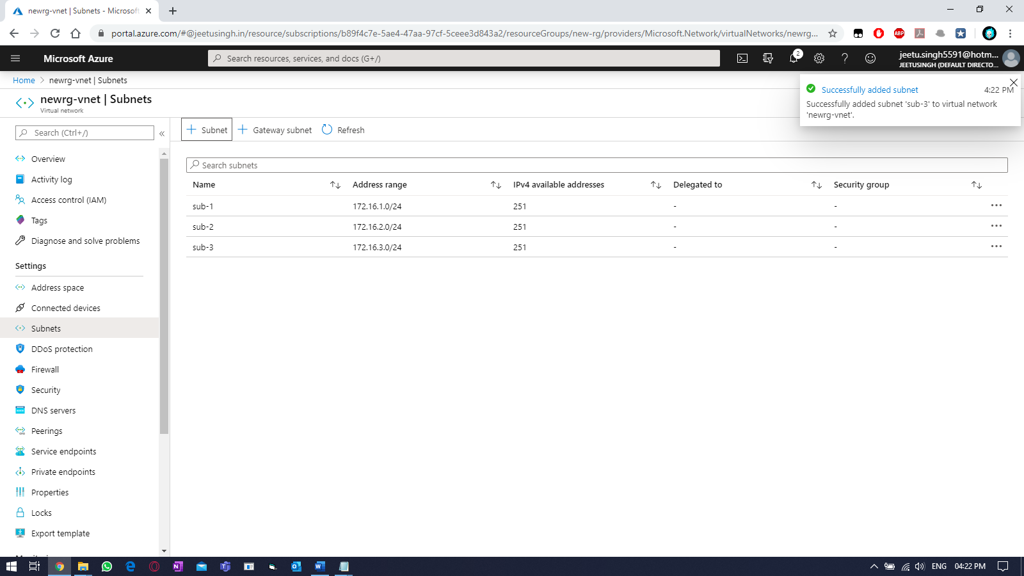

Adding DNS for the VNET.
Select “DNS servers” within your vnet & select “custom”, then fill your required valid DNS servers.
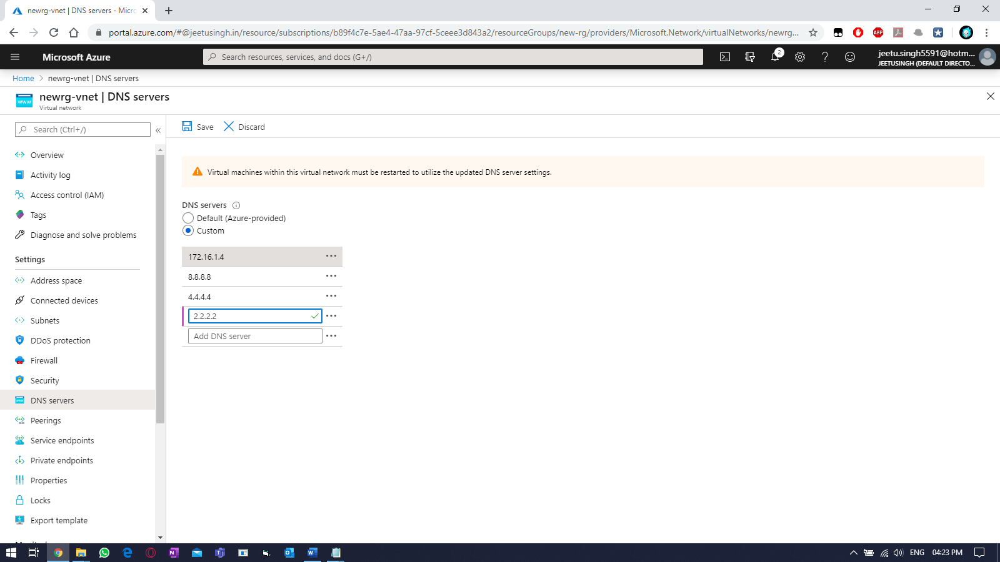

Practice Work No – 5 & 6:
Statement | Implementing virtual machines.
Objective | The main objective of the task is to create and manage Azure virtual machine (VM) using Azure portal.
Outcomes | After executing this, one should be able to create and manage the azure virtual machine (VM). Access virtual machine using RDP and Putty.
Prerequisites | Working Azure account, Internet
[Task]: Create a new VM using the vnet you created earlier (newrg-vnet) and use first subnet (sub-1) for the VM. Also use the storage created earlier. Connect to the VM using credentials provided earlier at the time of VM creation. And perform backup of the current VM.
Select the virtual machine (VM) tab from left side.
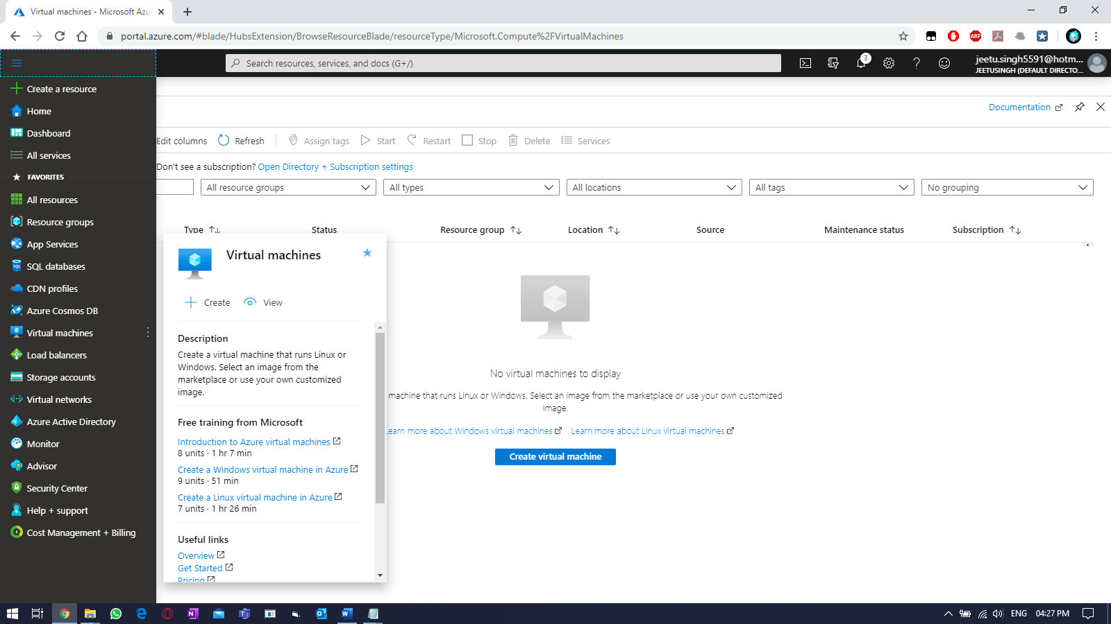
Click on “add” & fill the required details to create the VM.
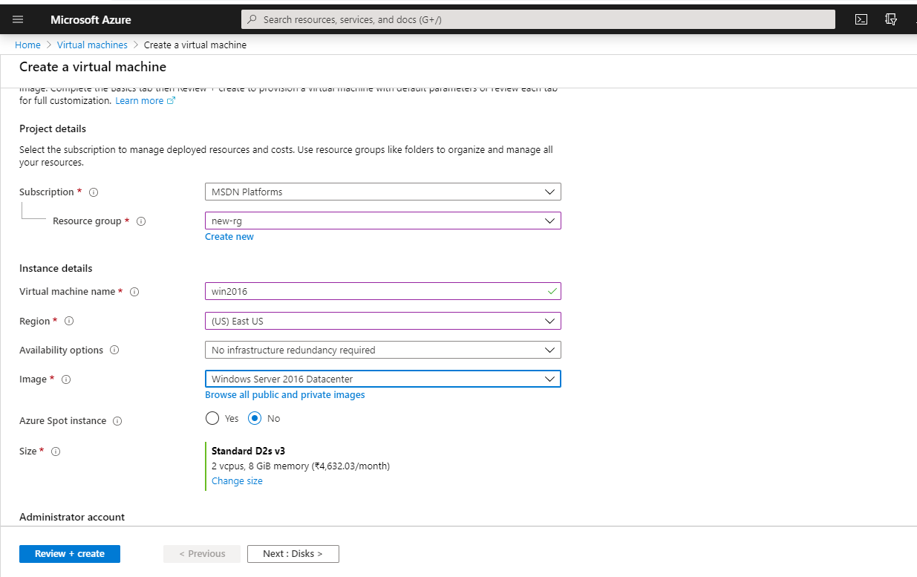
Provide username & password for the VM:
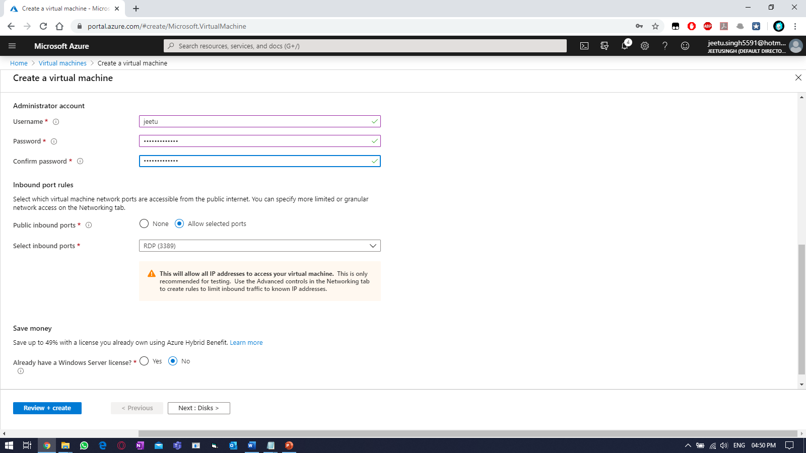
Click “Next: Disk >”
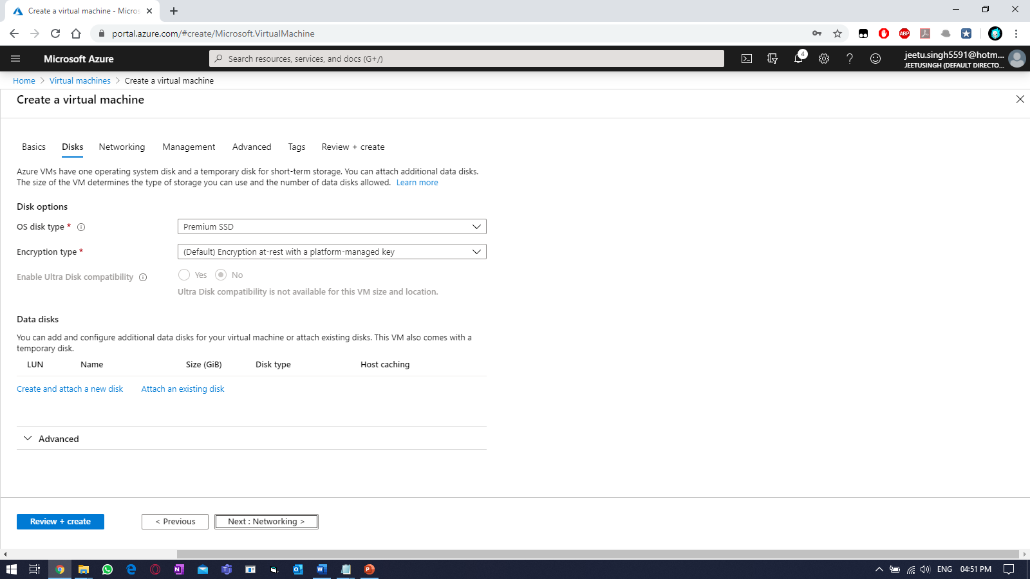

No changes required. Click “Next: Networking >” & select the virtual network created earlier and enable RDP port.
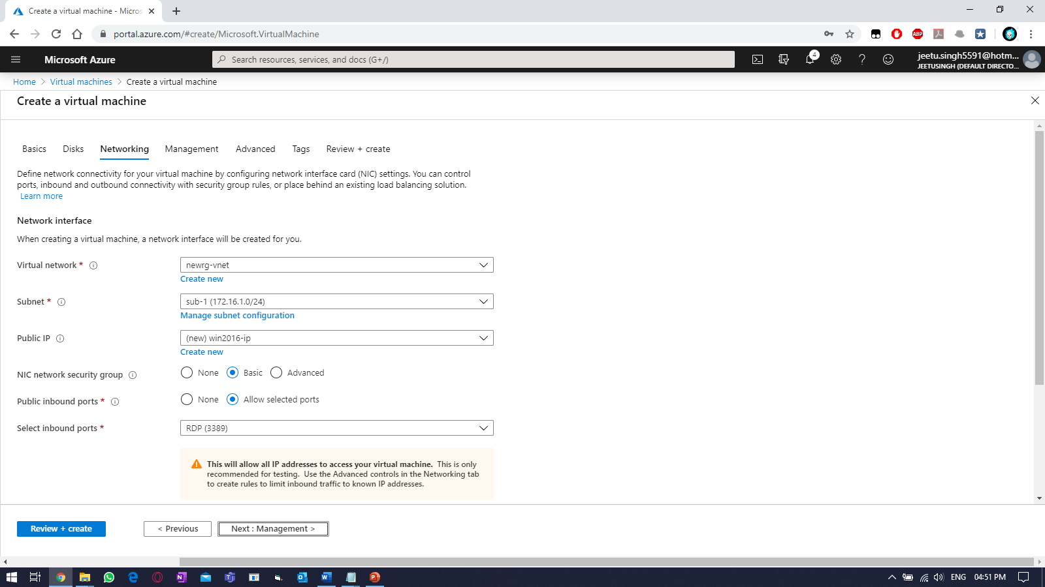
Select the storage account you created earlier and click “Next: Advanced >”
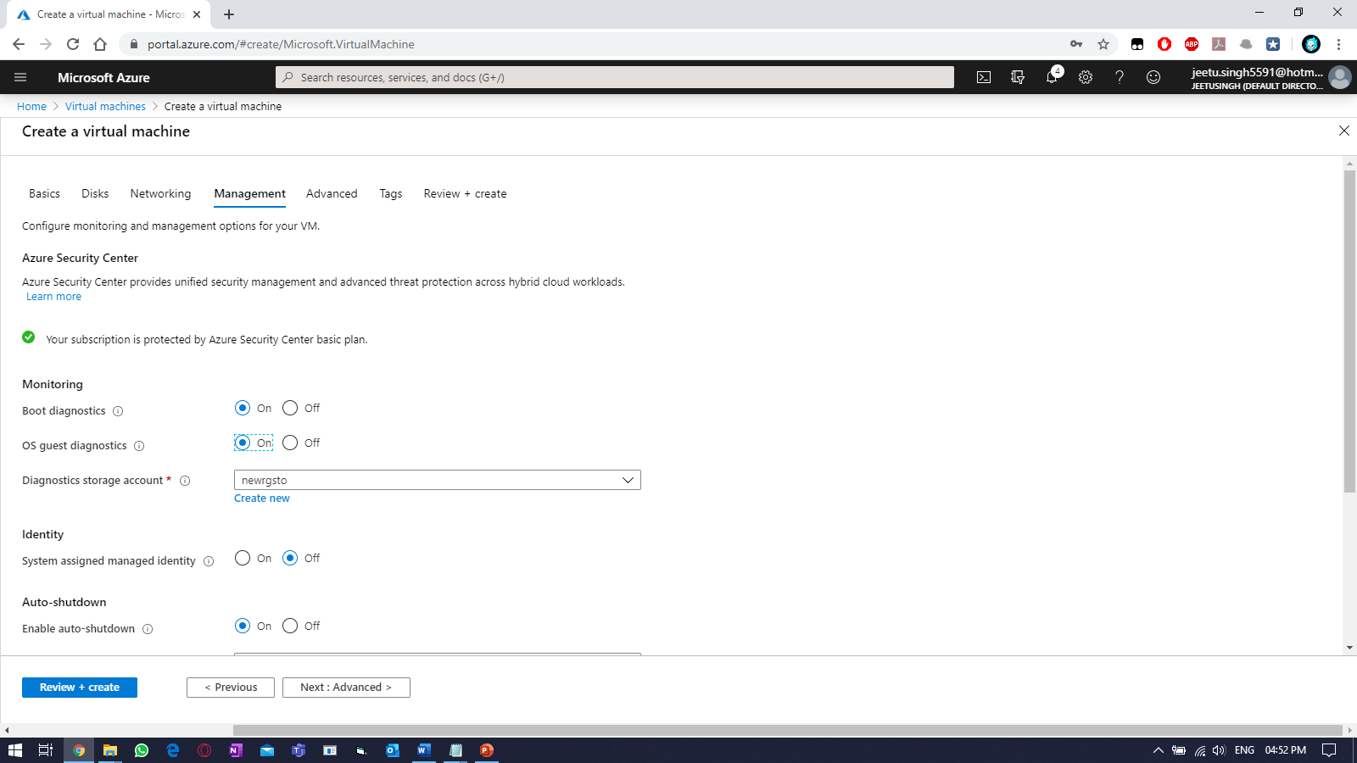

Nothing to change to in advanced, as no extension are to be installed.
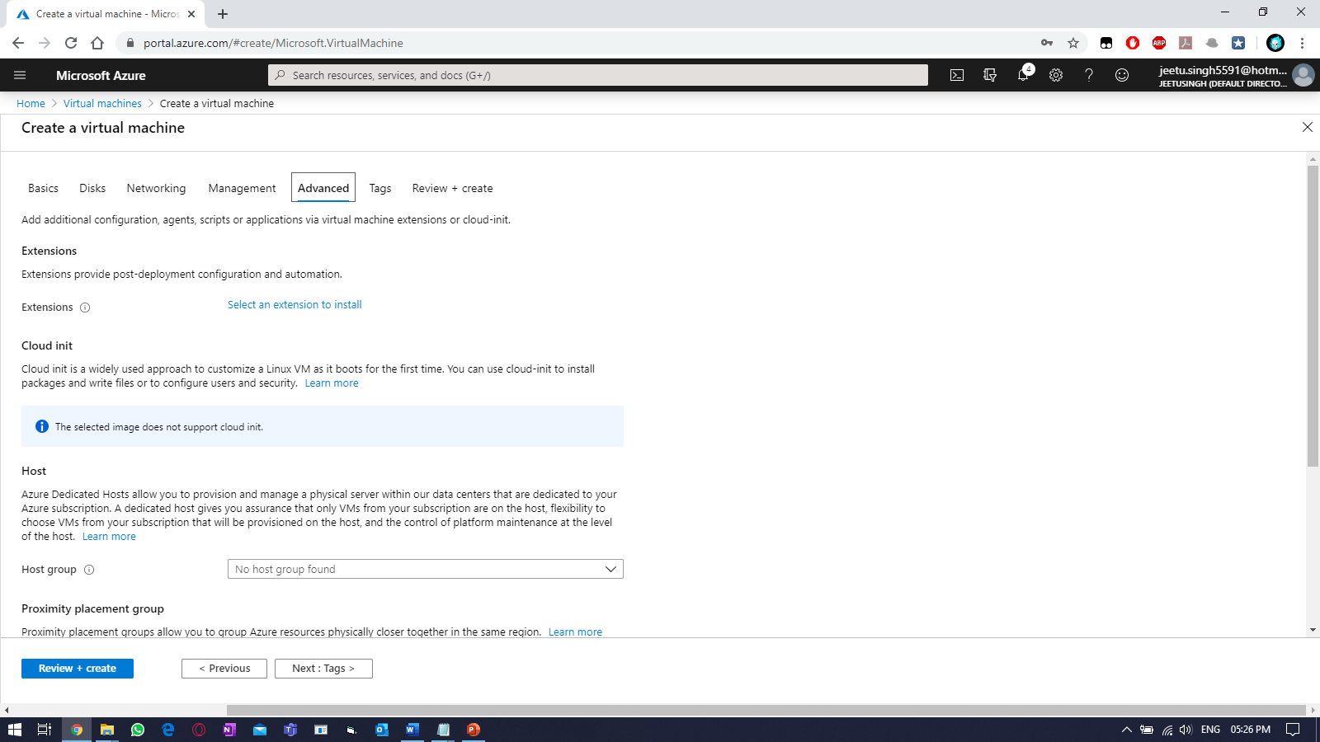
Attach the tags and create “Next: Review + Create”
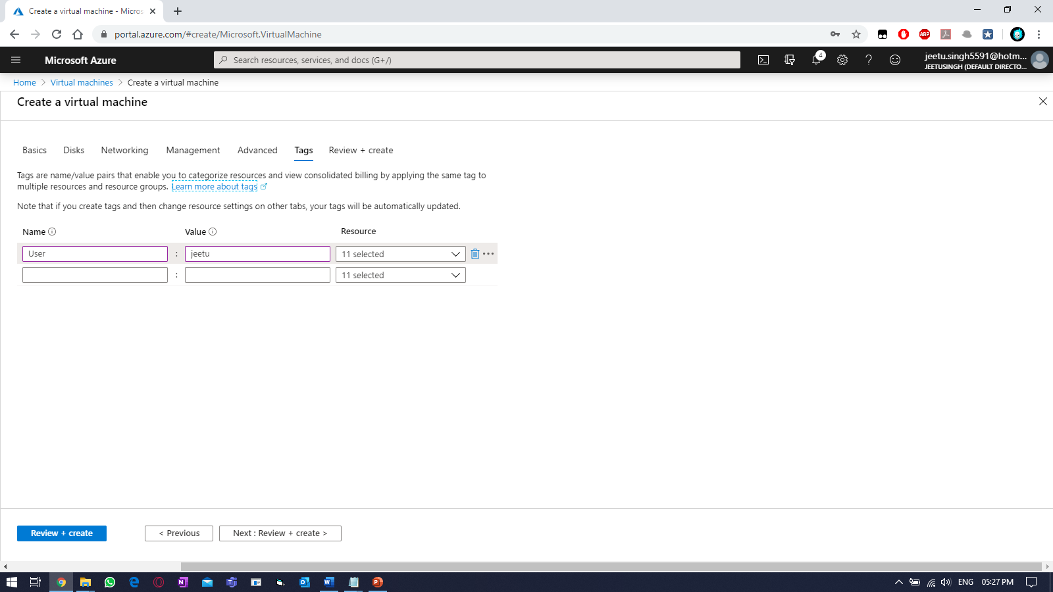

If validation is passed, then click “Create”.
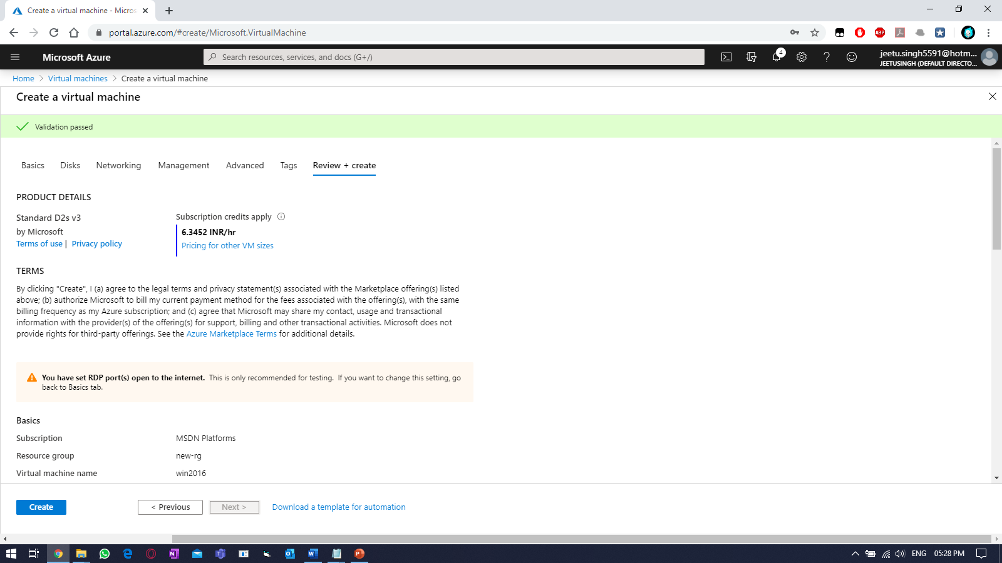
Click to “Go to resource”, once finished.
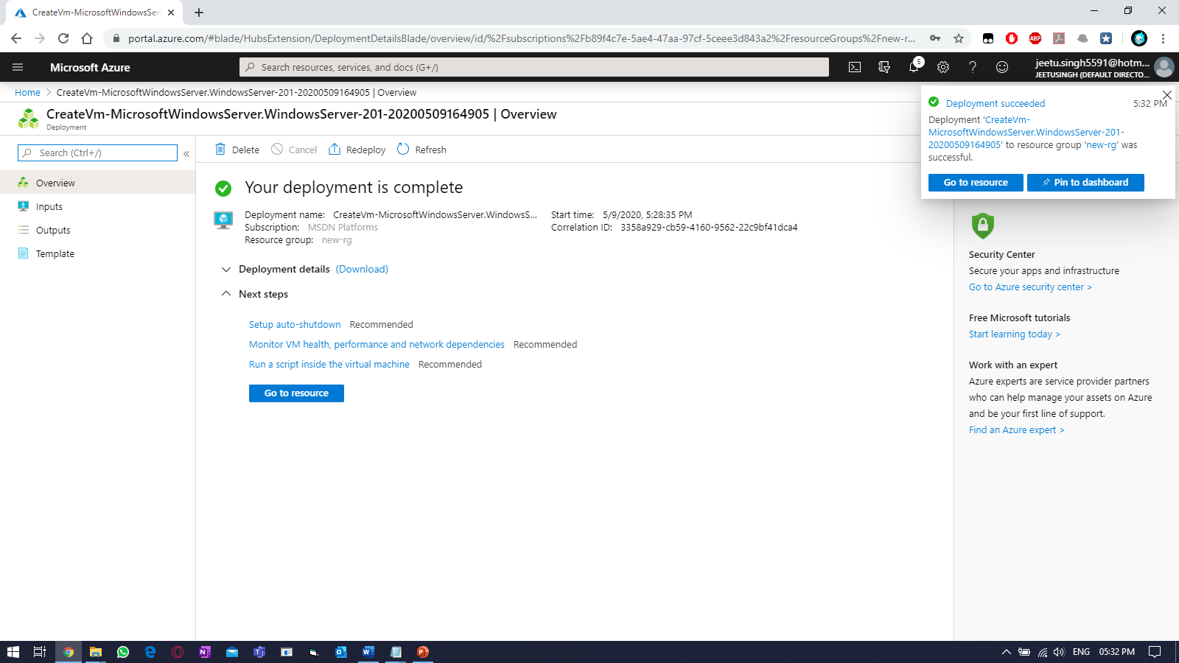

To connect to the VM, click on “CONNECT” and select RDP.
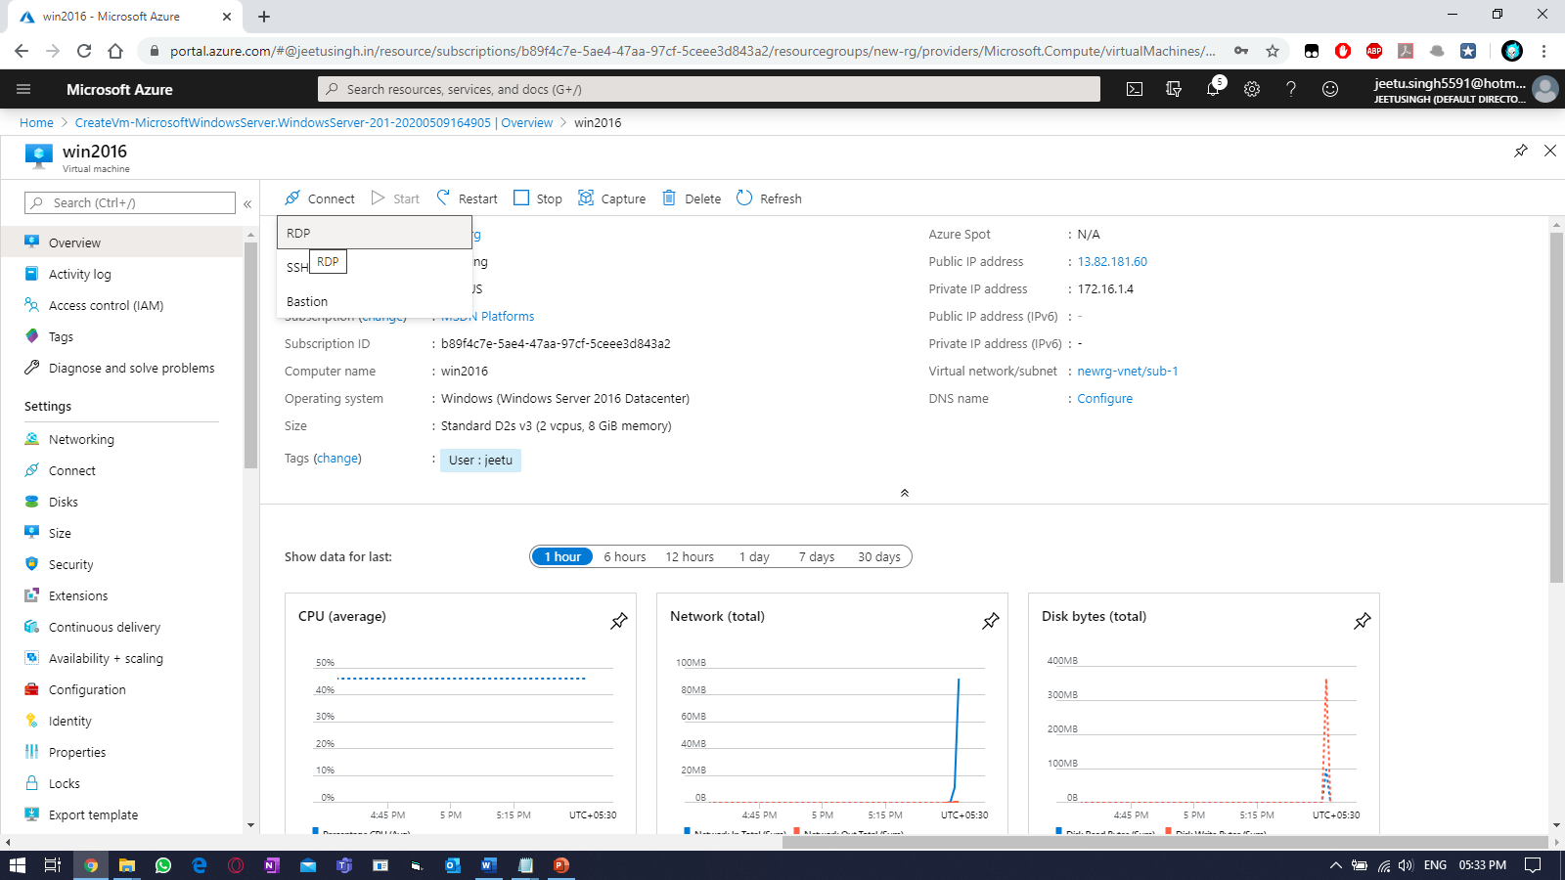
Download RDP & provide username & password.
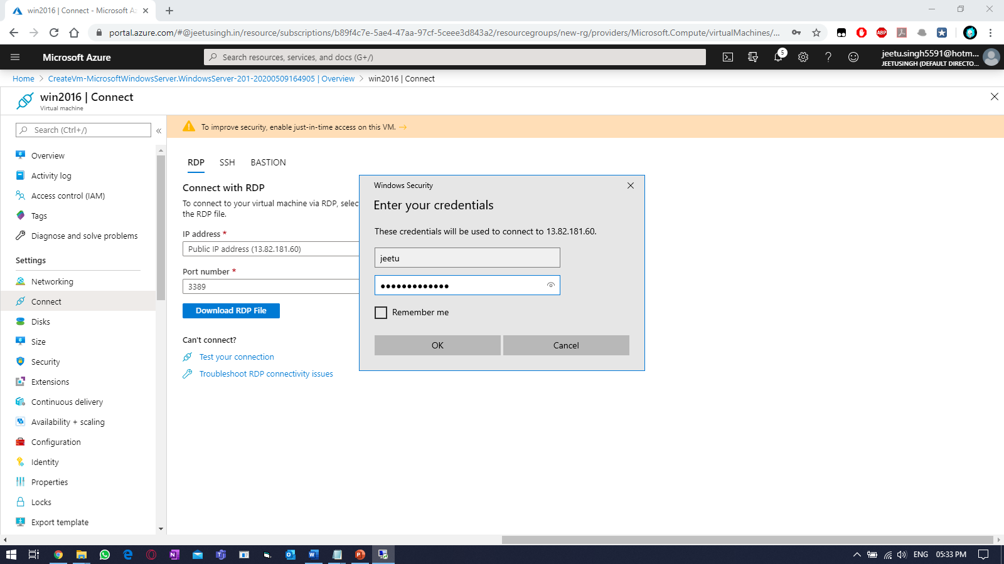

Verify:
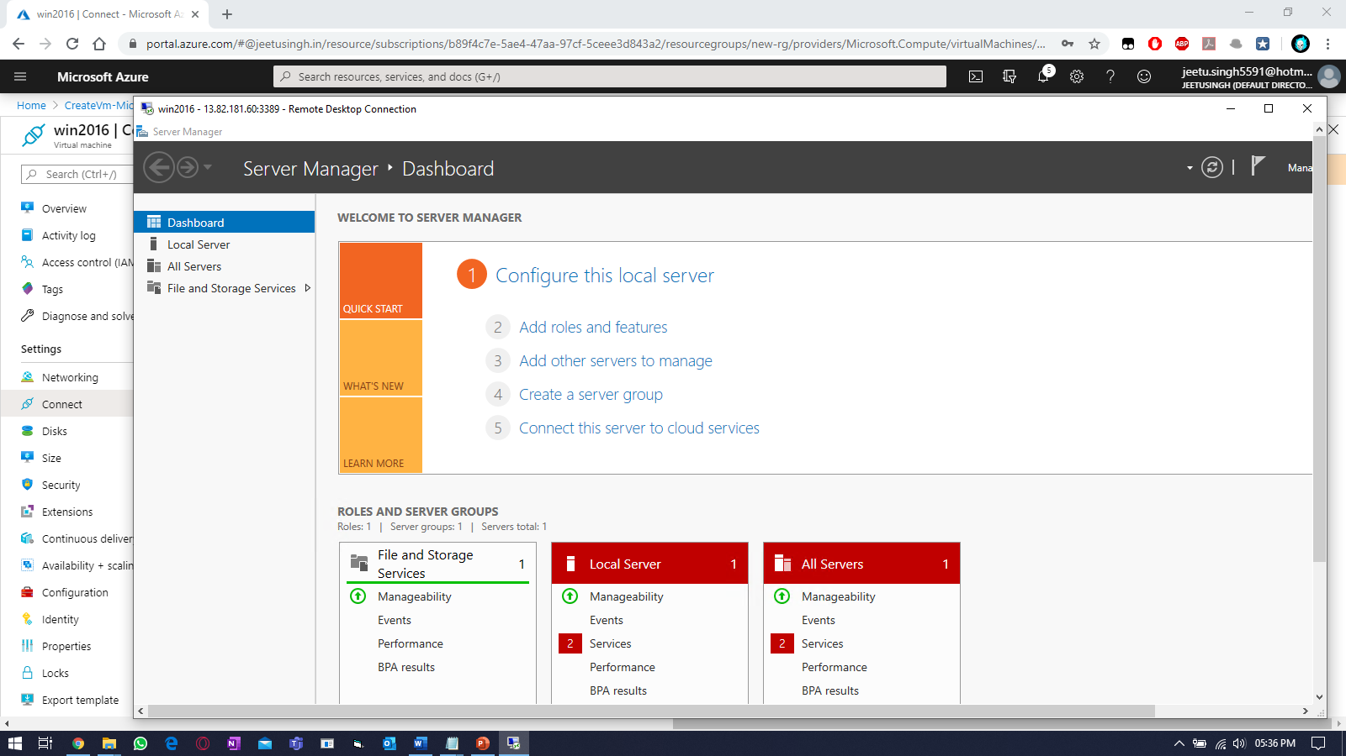
Perform the backup for the any windows VM. Select a VM & search for “backup” blade.
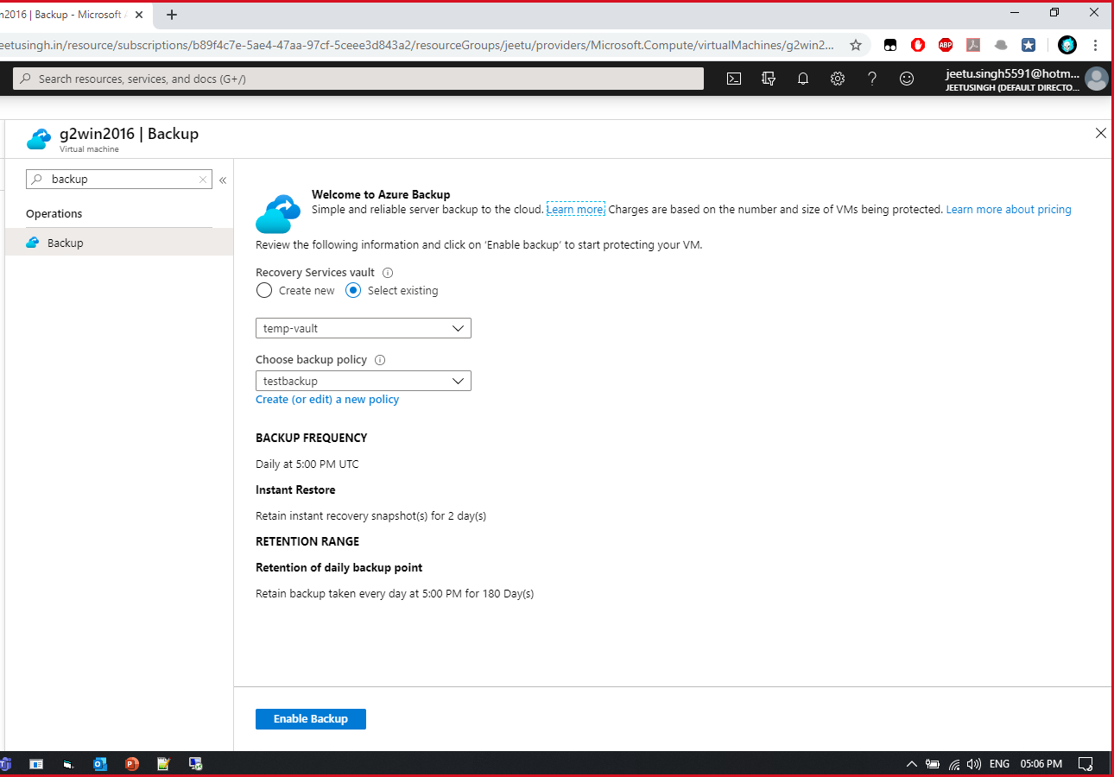

Enable backup & create backup policy.
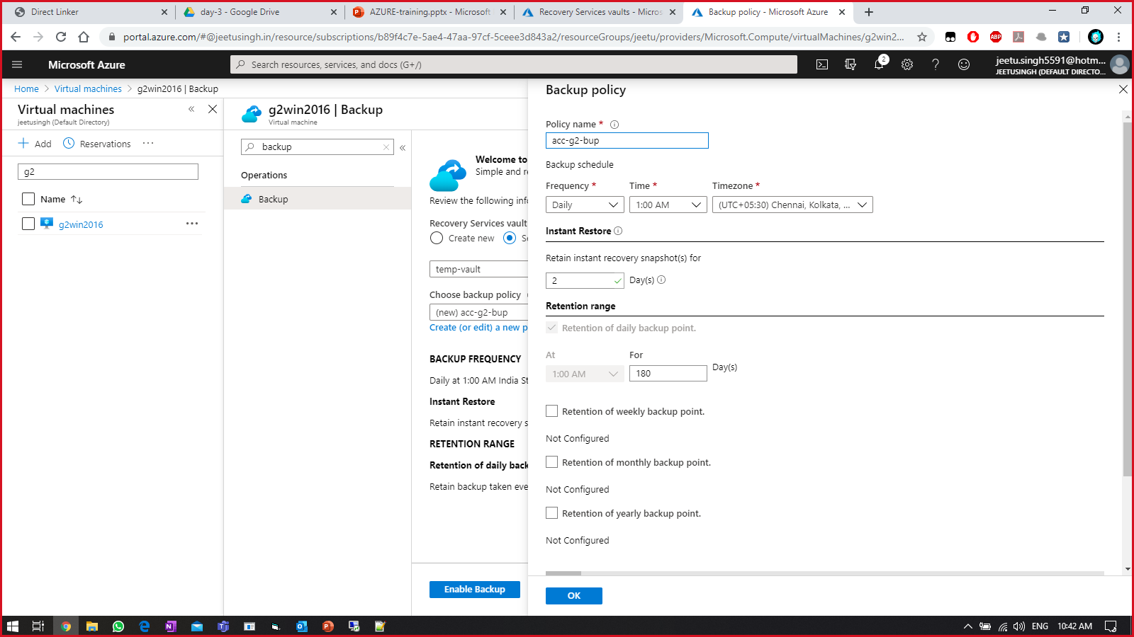
Once backup is ready,
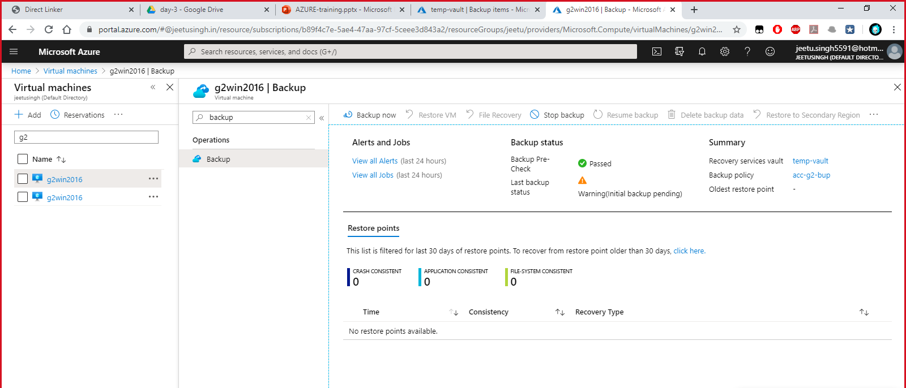
Select backup now, 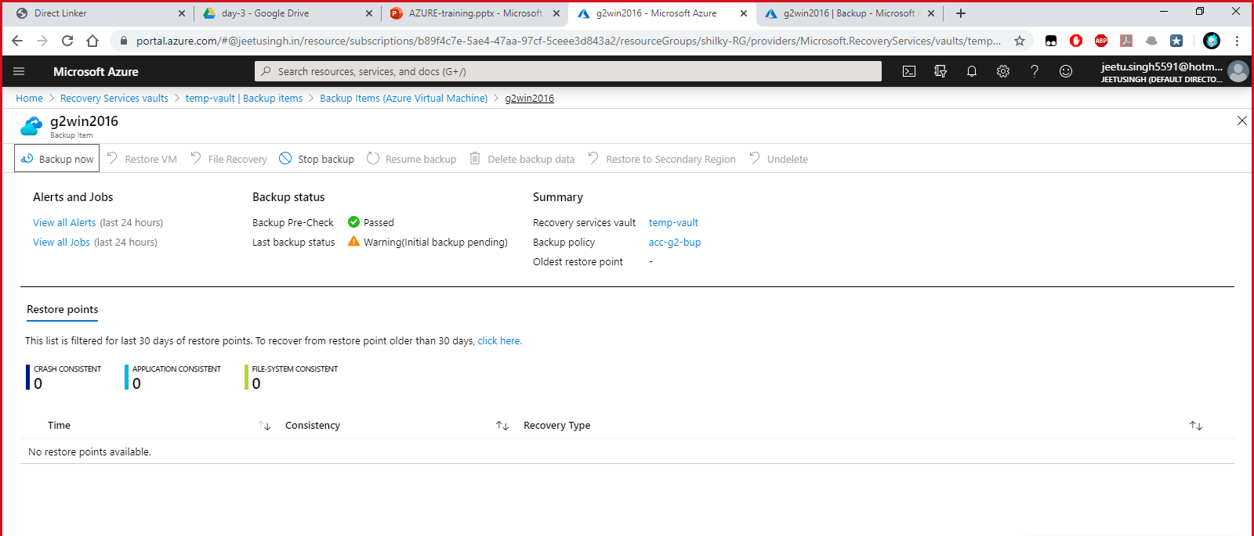
Select the backup time and click OK
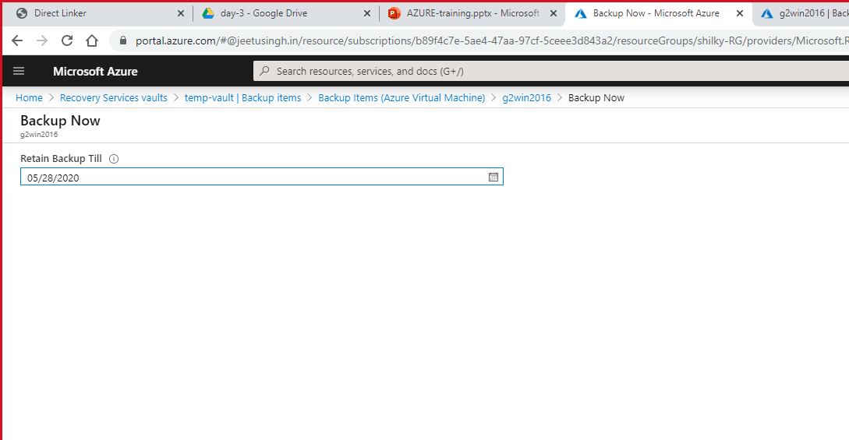
Something like this will be visible.
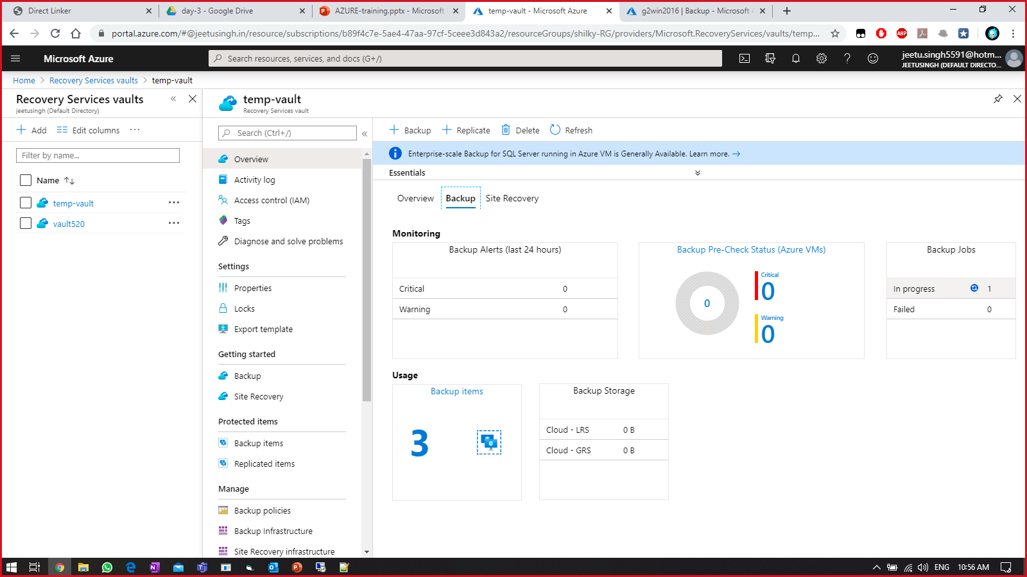

Connecting a linux machine using putty:
- Run putty on your system and enter the connection details of the linux machine as displayed in the example below and click open
